September 4th 2020
Hello and welcome to this week’s newsletter.
We have had another great week at Archbishop Hutton’s and a fantastic return following the Covid19 shutdown. We knew that we were ready for the return, following our successful work before the summer with three bubbles of key worker children. Our routines are all in place and everyone is following the new safety rules in a very sensible manner.
We are excited for the new term and new school year. Even though our classrooms and routines may be a bit different, we still have the same high expectations and will be setting ourselves challenging targets to help the children catch up with the great progress they were making pre-lockdown.

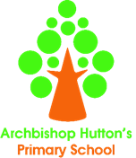
This week we have made a great start to the year. The children have been in for two days and we were all concerned about the return and expecting some reluctance and nervousness about returning. That said, attendance has been 100% and on the frequent visits I have made to every class the children have been excited to be back and totally engaged in what they are doing. Next week, we will begin the attendance and punctuality awards. The winners each week will earn 3 minutes for their class. At the end of term the minutes are added up and the children can decide how to spend them on a choice of activities.

Our usual celebration of learning will begin next week. All children have already started collecting team points and these will be added to the points they have already collected up to March 2020. If they are in line for a Planet Reward badge, they will receive this in their Bubble Celebration on a Friday afternoon. Any Role Models collected last year will also continue to count towards Outstanding Awards this term.
Each week, we now have three certificates which can be earnt. Mega Maths Hero, Writing Superstar and one Learner of the Week will be chosen for each class. As well as a certificate, they winner will receive 20 team points. Winners will be listed on the newsletter and feature on the Let’s Celebrate class page on our website.

- This term we will be unable to hold our usual Meet the Teachers meetings in school. This is due to Covid19 and the need for social distancing. Instead of this, we have posted a copy of our very detailed PARENT’S GUIDE TO OUR SCHOOL on your child’s class page. This guide includes all of the back to school information which would have been discussed during the meeting. I
have also posted the COVID19 – A SCHOOL GUIDE FOR PARENTS AND PUPILS on the class pages. This guide, which was sent to all families a few weeks ago, outlines the changes to our daily routines as a result of coronavirus. Together, these two documents should provide enough information and answer any questions you might have about the year ahead.

Should you wish to speak to the teacher, please do not hesitate to call and make an appointment for a telephone conversation.

- Thank you for your help with the packed lunch situation and the provision of a water bottle for class. I do need to ask that the water bottle contains only water as some children have been bringing in juice this week. If your child would like a drink of juice with their lunch, this is fine but it must be in their lunch bag and separate to their class water bottle. Remember too, all children can bring a fruit snack in for playtime if they wish.
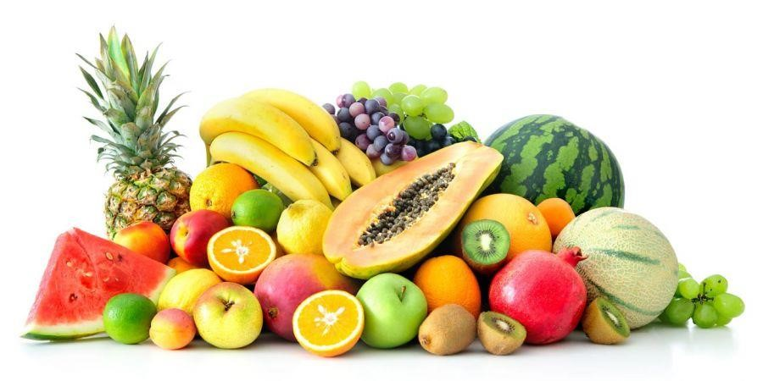

- Next week the class web pages will also feature the Knowledge Organiser for this term’s Healthy Body theme, along with a Skills Coverage document and a half term Class Newsletter. The newsletter will feature more information about this term’s work and class routines.

- We are very pleased to welcome Miss Massaro to our teaching staff. Miss Massaro has been with us since January, but as of yesterday began officially as our new Class 2 teacher. She is raring to go and has a lovely fresh new classroom with new carpet, blinds and a much needed lick of paint. The children in her class have settled in well – as have all our children – and are raring to go for the Autumn Term.

- Listen to this...The ABH Podcast. The fifth episode of our Podcast is now available for everyone to listen to. This special episode says goodbye to Miss Watson as she answers the questions of pupils and staff. There is also an amazing rap battle between members of Bubble 3. Made with the children in the lockdown bubbles, the podcast is a mix of jokes, poems, stories, teacher interviews and school news. We hope you enjoy listening as much as we enjoyed making it. Have a listen and we will be back with more in the next couple of weeks.
You can listen:
on Spotify: https://open.spotify.com/show/1BTxZHy1dICMPUr6RwyKi4 on RadioPublic: https://radiopublic.com/listen-to-thisthe-abh-podcastGbbRBx
on Breaker: https://www.breaker.audio/listen-to-this-dot-dot-dot-the-abhpodcast on PocketCasts: https://pca.st/jw7jhdw9

It is also available on apple podcasts and google podcasts - but they don't send a link. You just need to do a search!

- So, that’s all from us for this week. Please read the Parent Guide and look out next week for our Let’s Celebrate! winners.

