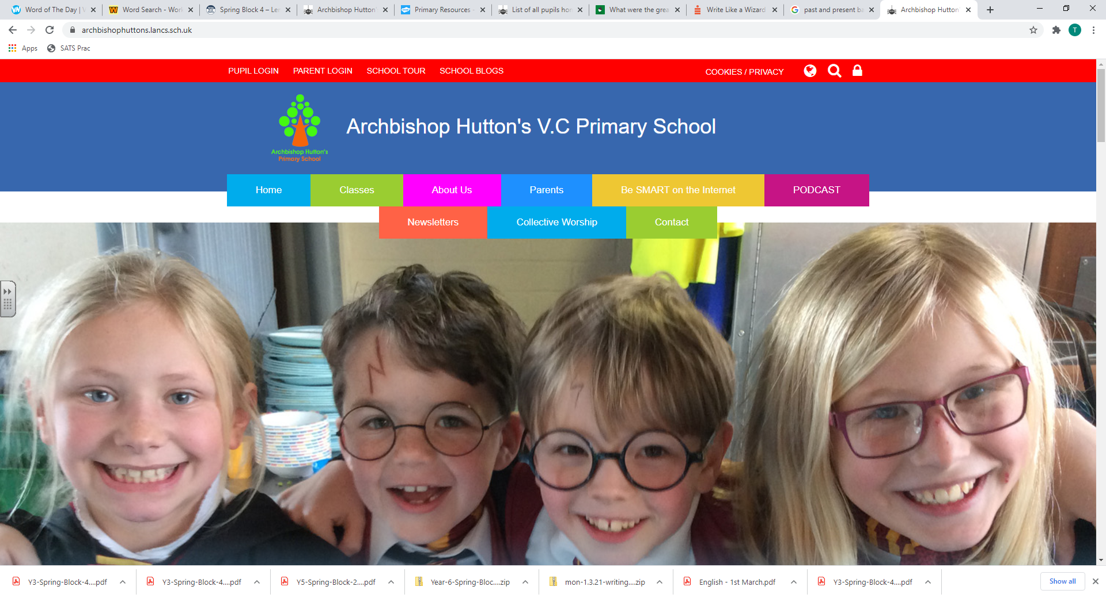

SEN Information Report
2025-2026

WHAT WE DO AT ARCHBISHOP HUTTON’S
At Archbishop Hutton’s, our pupils to have big ambitions and high expectations of themselves. We are an outward looking school, with a strong sense of our place in the local community and to that end we have created a curriculum that truly meets the needs of our children.
Our exciting curriculum is driven by our children and enables each child to develop academically, emotionally, creatively, socially and physically.
Our curriculum enables the children to share ideas, express their opinions and apply what they have learned in a wide range of meaningful contexts. It offers opportunities for all children to investigate, question, debate and challenge. We expect our pupils to be active learners, questioning, investigating, challenging themselves and sharing responsibility for driving their own learning. These qualities needed for successful learning are underpinned by our focus on independence, inquisitiveness and resilience.
HOW WE DO IT
At the heart of our curriculum are the core subjects of English, Mathematics & Science. What we teach and learn in these areas is then developed further in our wider curriculum work.
This wider curriculum is organised into units of learning or themes. Meaningful links are made with other subjects, securing prior learning and develop learning further. It is planned and taught through carefully sequenced lessons where the critical content of each subject is covered so every child can gain a deep understanding. There is a focus on key vocabulary, which will be covered in the theme and which will enrich the children’s understanding as a whole.
The learning is planned, reviewed and adapted yearly to ensure that children’s knowledge base builds effectively over time to ultimately ensure they are ready to meet the expectations of secondary school.
This knowledge has three main aspects:
- Substantive Knowledge – Key Facts and Figures
- Procedural Knowledge – the development to skills and techniques
- Disciplinary Knowledge – the ability to apply the substantial and procedural knowledge to develop their own learning, enquiries and bodies of work
Where possible, learning will be supported and enriched by field study, visits, visitors, workshops, artefact boxes, role-play and practical resources.
These enhancements form a key part of every child’s learning journey through our school and we believe they are essential elements in developing engaged, curious learners.
WHAT WE PROVIDE
- A stimulating environment for developing inquisitive, independent and resilient lifelong learners who work hard and strive for excellence.
- A culture of working independently and collaboratively, where we see getting something wrong as part of learning how to get it right
- A safe place where all children are encouraged and supported.
- Engaging learning where enquiry and challenge are fully embraced to open the world up to all.
Exciting opportunities to promote our children's personal development and understanding of their own emotional and physical wellbeing.

SEND: Adapting our Curriculum Offer

HOW OUR LEARNING IS ADAPTED TO ENSURE EVERYONE ACHIEVES AND MAKES PROGRESS
We understand that a child’s area of need may change throughout their school journey.
Some children’s levels of need (especially those with a diagnosed condition) will mean that they have special educational needs for their entire school career.
Others may have fluctuating or isolated needs. For example, putting in place an intervention to improve gross motor skills in the early years could lead to issues being successfully addressed, bringing skills back in line with age expectations.
There are four types of Special Educational Needs and Disabilities (SEND) identified by the Department for Education:
- Communication and Interaction
- Cognition and Learning
- Social, Mental and Emotional Health
- Sensory or Physical
When a pupil has SEND, their needs will fit into one or more of these categories.
A school’s provision for SEND is defined as support which is additional to or different from that which is available to all pupils.
We know that many of the ways we support our children with SEN are simply an extension of our good practice in the classroom. However, often more specific strategies may be particularly useful in supporting particular needs.
Therefore, when we plan lessons we:
- Ensure tasks are effectively differentiated and ambitious in their outcomes for all students. Organise work for learners with SEN in smaller chunks with plenty of opportunities for revisiting and over learning, where appropriate. This might involve smaller follow-up tasks.
- Use technology where appropriate to scaffold the learner. This may include equipment, apps, or specialist software which can effectively support SEN.
- Deploy other adults in the classroom to effectively facilitate learning.
- Incorporate flexible grouping – do not always group children with similar SEN together; allow them to learn from their peers.
- Plan in the use of talk partners – this gives children with SEN access to peer support and the ability to rehearse their responses.

We always ensure that our communication with the children we teach is appropriate and is adapted both when spoken and written in order to support all children.
When we communicate with our classes we:
- Keep instructions clear and concise.
- Deliver instructions facing the children.
- Don’t issue multiple instructions at once.
- Give children an opportunity to repeat instructions back to a peer or adult.
- Accompany verbal instructions with visual aids for those who need it.
- Allocate other adults (or peers) to re-word and re-frame instructions and information for those with Speech, Language and Communication needs.
- Verbalise our thought process whilst modelling activities, including strategies to remember what you need to do.

We complement our high-quality teaching with small group and one-to-one interventions
Often, we have learners in our classes who need to access particular interventions in order to fulfil their potential, in addition to the high-quality whole-class teaching that we are providing.
Inventions are allocated for a pre-agreed period of time, accompanied by measurable goals, and regularly evaluated.
All teachers to produce a provision plan detailing the interventions that are taking place within the class. This is adapted regularly.
All learners have a statutory right to a broad and balanced curriculum, so we take care to ensure that those children with SEN are not consistently removed from the same lessons for interventions.

We understand that children can experience both academic and social barriers due to their SEN, meaning that they are unable to reach their personal potential.
Without proper support or accommodations in place, those barriers could manifest in anxiety, disengagement, and frustration, sometimes resulting in challenging behaviours within school.
These could include:
- Withdrawn behaviours, including expressing anxiety, school phobia, truancy, and social isolation.
- Disruptive behaviours, such as calling out in class, angry outbursts, swearing, screaming, or refusing to follow instructions.
- Violent and/or unsafe behaviours such as physically harming themselves or others, running away, and damaging property.
There could also be changes to a child’s needs on occasion of a change in circumstances – ie: children experiencing grief or with other social, emotional and mental health needs. In these cases, staff would adapt their approach appropriately.

It is therefore key to our commitment to helping all of our children to achieve their true potential that we make learning accessible to all and achievement and progress attainable for everyone.

How do we identify a child with SEND and how do we assess their needs?
At Archbishop Hutton’s School, we recognise that students make progress at different rates and not always in a steady, linear pattern. Therefore, students are assessed as having SEND in a variety of different ways, including the following:
- Liaison and information from previous settings such as pre-schools, nurseries or a previous school
- The pupil performing significantly below the expected levels
- Concerns raised by a Parent/Carer
- Concerns raised by a Teacher
- Liaison with external agencies e.g. Educational Psychologists, Paediatricians, Occupational Therapists etc.
We believe early identification is vital to supporting children with SEND and the school works closely with parents and outside agencies to best support children in school. The school uses appropriate screening and assessment tools from both school resources and where needed, outside agency involvement.

How do we involve parents and consult with them about their child’s education?

At Archbishop Hutton’s School, we ensure teachers and other staff build positive relationships with parents and pupils in their class so that any concerns can be raised quickly and sensitively.
When children are enrolled at our school, parents are invited to meet with the Headteacher to discuss their child’s needs. During these meetings, the Headteacher and parents have the opportunity to discuss the child and share any information that may be needed to help the child settle into school and access learning opportunities fully. The Headteacher then shares this information with relevant teaching staff.
The school operates an ‘Open Door’ policy and has two formal Parent Teacher Meetings every year to provide opportunities to discuss the children’s progress. Parents can request further meetings at any time when they have any concerns or worries that they wish to discuss with Teachers. In July, an annual report is sent to all parents outlining the child’s achievements during the year.
When a child has SEND, Parents/Carers are encouraged to be regularly involved with the school. Where advice has been given by outside agencies or there is a change in provision, the school ensures this is shared with Parents/Carers.
How do we involve and consult the children about their education?
Children are encouraged to be involved in their education through:
- Taking an active part in all lessons
- Responding to marking and verbal feedback
- Contributing to meetings where targets are set between the Teacher and the child
- Completing homework tasks and projects
Where a child has a pupil profile, focussed time with the Class Teacher or Teaching Assistant is given to discuss learning needs, progress towards targets and next steps. Children who have an Educational Health Care plan (EHC), have the opportunity to contribute to annual reviews either verbally or in writing.
How do we adapt the curriculum and the learning environment for children with SEND?
All children including those with SEND are encouraged to take a full and active part in the whole curriculum and where needed advice is sought to ensure this is achieved in the most effective way. It is the Teacher’s role to differentiate resources and activities to ensure all pupils can access the learning. This can mean that teachers plan:
- Visual, auditory or kinaesthetic activities.
- Small group or 1-1 learning
- Pre-teaching content or vocabulary.
- To provide additional apparatus or materials.
- To adapt and adjust resources and materials to make them accessible for students with specific learning difficulties.
- To adapt the learning environment, seating arrangements and accessibility of resources etc.
When needed, the school will provide the teacher or teaching assistant with the appropriate training and advice to ensure adaptations meet the child’s needs.
How do we assess and review the progress that children make and how do we involve them and their parents?
Progress of all children throughout school is tracked using either the Early Years Foundation Stage Profile or the Key Stage 1 & 2 KLIPS (Key Learning Indicators in Performance). Teachers meet regularly to discuss pupil progress and identify appropriate support to close learning gaps. When there are concerns relating to individual children’s learning, the Teacher and SENDCO will discuss how their needs can be effectively met and what support or additional assessments may be required. This may involve taking advice from external specialists and/or include the use of diagnostic and other assessments to determine the exact areas of needs and strategies recommended. When external specialists are involved directly with the pupil, parental consent will be sought first. When additional support or intervention is required, pupils and Parents will be involved in the planning process as much as possible. The progress of the pupil will be reviewed at the end of the specified period of intervention. This review will form the basis of further assessment and planning. Meetings with pupils and parents happen at least once a term.
How do we support our pupils with SEND as they move on to High School or move to another school?

Each year pupils visit their forthcoming Secondary School for taster sessions. Secondary Teachers from the local schools meet Year 6 teachers to support the transition from Year 6 to Year 7. For children who have an EHCP in place, the school arranges an early review of child’s needs in the Autumn term to ensure that there is a clear transition plan with key milestones and timescales to support both the pupil and the Parents during the transition, which is an anxiety provoking experience. When a pupil transfers to another school, transfer documents, including full records of their special educational needs, will be sent to the receiving school. On transfer to Secondary School the Year 6 Teacher and SENDCO
How do we know if what we provide for the children is effective?
There are several ways that we assess the effectiveness of the support provided:
- We see evidence that the pupil is making progress academically against age related expectations and/or that the gap is narrowing.
- Verbal feedback from the Teacher, SENDCO or external agency. This is shared with Parents/Carers in reviews, parent teacher meetings or informal meetings.
- Formal or informal observations of the pupil at school.
- Feedback and discussions with Parents and children.
- When pupils make sufficient progress, they will be removed from SEND support plans and intervention programmes.

How are children with SEND enabled to take part in all the activities available at school?
- Every child is encouraged to take a full and an active part in all areas of school life. When there are barriers to children or families being able to engage in aspects of school life, staff work closely with them and outside agencies to look at the best ways to overcome any issues.
- To ensure that all children have the opportunity to attend school visits, residential trips and outdoor learning days we work closely with specialist teachers and health care professionals to complete care plans and risk assessments for children with physical health needs or medical needs e.g. Diabetes, Asthma and Epilepsy.

How do we involve and work with other professionals such as local authority support services and other organisations to meet the needs of our children?
As a school we work closely with any external agencies that we feel are relevant to supporting individual children’s needs within our school including:
- Inclusion Disability Schools’ Service
- Health Services including: GPs, School Nurse, CAMHS (Child and Adolescent Mental Health Service), Clinical Psychologist, Paediatricians, SALT (speech and language therapists,) Occupational Therapists and Physiotherapists
- Children’s Services including: Family Support Workers, Social Workers; Educational Psychologists and Specialist Advisory Teachers.
When appropriate the school will use the Common Assessment Framework (CAF) process to identify children in need of additional behavioural, mental health or social support and act as the lead professional in the team around the family (TAF) meetings.

How staff are trained to be able to support the children with SEND in the school
All staff receive SEND training in school, at least yearly.
Staff working closely with particular children with SEND receive training and support tailored to the needs of the child. This may be through attending training courses, or receiving guidance and advice from outside professionals, e.g. ASD specialists, educational psychologist and speech and language therapists.
Where a child is not making progress despite the school making adaptations, the school will draw on available outside professionals to give expert guidance. This may include support services offered by the local authority as well as private providers.

How do we support children with emotional and behavioural difficulties?

The pastoral care and nurturing ethos of Archbishop Hutton’s school is a real strength of the school.
When it is identified that a child may need support or supervision whilst outside playing, a teacher or teaching assistant is assigned to observe the child to ensure that both they and their peers have a positive experience.
When children start school in the EYFS or in other year groups mid-school year, they are given allocated a ‘Key worker’ or ‘buddy’ to show them around and help them to settle in, as well as being someone that they can go to if they have any issues. This system is very effective in supporting children to make friends and to support those children who have difficulties at playtime.
Our P.S.H.E (Personal Social and Health Education) Scheme of Work includes Health and Well-Being (Healthy Lifestyles, Growing & Changing and Keeping Safe) as part of teaching & learning for every year group.

We have detailed whole school behaviour management policy and anti-bullying policies that parents can access on the school website.
The school also provides opportunities for children to attended assemblies & workshops run by agencies such as Childline and the NSPCC.

Who is the SEND Co-ordinator (SENDCO) and how can we contact them?
The school SENDCO is Mr Stuart Pugh
Mr Pugh is responsible for the operation of the SEND policy and co-ordination of specific provision made to support individual children with SEND. She can be contacted via the school office 01524 734305 or by email at head@archbishophuttons.lancs.sch.uk

What should I do if I have a concern or complaint about the provision for my child?

The complaints procedure for Special Educational Needs mirrors the school’s complaints procedures. Should a Parent or Carer have a concern about the special provision made for their child, they should in the first instance discuss this with the Class Teacher. If the matter is not resolved satisfactorily parents can:
- Discuss the problem with the SENDCO
- Discuss the problem with the Headteacher
- More serious on-going concerns should be presented in writing to the SEN Governor (Mr R Slaughter), who will inform the Chair of Governors (Mrs M Jackson)

Where can I find information about the authority’s Local Offer?
As part of Lancashire County Council, the Lancashire Local Offer should be your first point of reference for any further information. This can be found at:
http://www.lancashire.gov.uk/children-education-families/special-educational-needs-and-disabilities.aspx

Date approved: October 2024
Next Review: October 2025
Signed: M. Jackson (Chair of Governors, Mrs. M. Jackson)
Signed: S. Pugh (Headteacher, Mr S. Pugh)

