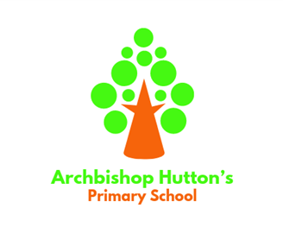

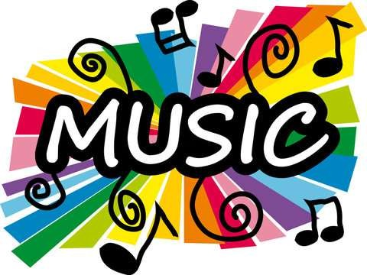Music Development Plan Summary Archbishop Hutton’s VC

Primary School

***November 2024***

***Reviewed September 2025***

# Overview

|  |  |
| --- | --- |
| **Detail** | **Information** |
| Academic year that this summary covers | 2025 - 2026 |
| Date this summary was published | September 2025 |
| Date this summary will be reviewed | September 2026 |
| Name of the school music lead | Chloe Barclay |
| Name of school leadership team member with responsibility for music (if different) | As above |
| Name of local music hub | Lancashire |
| Name of other music education organisation(s) (if partnership in place) | LMS (Lancashire Music Service)  Young Voices |

This is a summary of how our school delivers music education to all our pupils across three areas – curriculum music, co-curricular provision and musical experiences – and what changes we are planning in future years. This information is to help pupils and parents or carers understand what our school offers and who we work with to support our pupils’ music education.

# Part A: Curriculum music

## This is about what we teach in lesson time, how much time is spent teaching music and any music qualifications or awards that pupils can achieve.

* We teach the National Curriculum for Music using our own scheme of work which includes materials from Kapow!, Charanga, Young Voices and a range of singing materials. The school music curriculum is informed by the model music

curriculum (March 2021), non-statutory guidance for teaching music from Key Stages 1 to 3.

* + Music is introduced in the **Early Years** (Reception) as part of the daily activities both inside and outside the

curriculum. There are lots of opportunities for singing and making music using a wide range of instruments and environmental objects.

* All classes from **Years 1 to Year 6** have a weekly 40m minute long music lesson which gives opportunity for skills to be learned and developed.
* Every week, classes come together to develop singing skills in our Singing Assembly. In this assembly, children learn to perform new songs – incorporating the skills of singing in unison and in increasingly complex parts.
* These sessions also develop percussion skills, working in cross school groups.
* KS1 work on performance skills each Autumn Term as they prepare for their Nativity and Christmas Concert performances.
* KS2 children are offered musical lessons with a tutor. Parents pay for these lessons and the children work towards a termly concert.
* In KS2 children have two terms of instrumental lessons with a tutor from Lancashire Music Service (LMS). Once in Class 3 and again in Class 4.
* All Upper KS2 children work across the Autumn term to learn and perform the songs for Young Voices. This provides opportunities for the development of performance skills.

**We aim to ensure that all pupils:**

* perform, listen to, review and evaluate music across a range of historical periods, genres, styles and traditions, including the works of the great composers and musicians
* learn to sing and to use their voices, to create and compose music on their own and with others, have the opportunity to learn a musical instrument, use technology appropriately and have the opportunity to progress to the next level of musical excellence
* understand and explore how music is created, produced and communicated, including through the interrelated dimensions: pitch, duration, dynamics, tempo, timbre, texture, structure and appropriate musical notations

# Part B: Extra-curricular music

## This is about opportunities for pupils to sing and play music, outside of lesson time, including choirs, ensembles and bands, and how pupils can make progress in music beyond the core curriculum.

**Instrumental lessons:**

Pupils from Year 3 can access 1:1 (PDP) or small group instrumental lessons on:

* woodwind instruments (focus on flute and recorder)
* keyboard
* guitar
* percussion (drums)
* vocal skills / singing

and are taught by an outside tutor. All pupils are provided with an instrument that they can take home to practice on.

These extra-curricular lessons are chargeable in line with the school’s Charging and Re- missions policy. However, any child who would like to have a lesson but would be pre- vented from doing so on financial grounds can apply for subsidised / free tuition. Each case will be taken on its own merits.

**Ensembles:**

The school offers children weekly opportunities, in our singing assemblies, to perform as part of an ensemble. They learn and perform together as a choir as part of the whole school Nativity performance. The annual Young Voices in Manchester gives KS2 the chance to perform together and as part of a larger ensemble.

# Part C: Musical experiences

## This is about all the other musical events and opportunities that we organise, such as singing in assembly, concerts and shows, and trips to professional concerts.

**Singing in school**

Singing is a big part of the life of our school. We sing daily in our whole school worship and our Thursday assembly is singing based – singing known songs as well as learning new ones.

**School concerts and shows**

All children will take part in two concerts each year to which parents and friends are invited. They are:

One of:

* EYFS and KS1 Nativity
* KS2 Christmas concert
* KS2 instrumental performance (following Lancs Music Service tutoring)
* Annual Young Voices performance for parents and peers
* Year 3 – 6 termly music performance
* Year 6 Leavers production

All children are included and encouraged to take a full and active part in the rehearsals and productions.

## Trips

* **Choir** children go to Young Voices each year in Manchester – this allows them to experience live music on a grand scale
* We seek to facilitate trips to other events as and when they happen and are advertised. All children attend at least one theatre visit per year to see music performed.
* When a charge is needed (e.g. for entry to the event or for transport) this is in line with the charging and remissions policy. Parents can apply for support if needed. The friends of Archbishop Hutton’s also supplement these costs.

# In the future

## This is about what the school is planning for subsequent years.

As can be seen in the information contained in this document the school already has a strong musical presence.

The use of Kapow has helped teachers become more confident in their ability to teacher a structured Music curriculum.

We constantly keep the music curriculum under review and look for new resources / materials to use along with opportunities to take part in other music making in the locality (e.g. special events / touring performances etc).

The children’s love of singing has led to us looking to develop a KS2 choir .

We are also in the process of planning and Arts week, where Music would play a major role alongside poetry, painting and drama.

**Further information**

The Department for Education publishes a guide for parents and young people on how they can get involved in music in and out of school, and where they can go to for support beyond the school.

The Lancashire Music Hub website contains lots of information on music making opportunities across the area along with the development plan:

https://[www.lancashiremusichub.co.uk/site/](http://www.lancashiremusichub.co.uk/site/)