Year 6 Christianity - God
Year6 Key Question (to be used all year): Is life like a journey?
Focus Question (for this investigation): How do Christians mark the ‘turning points’ on the journey of life?

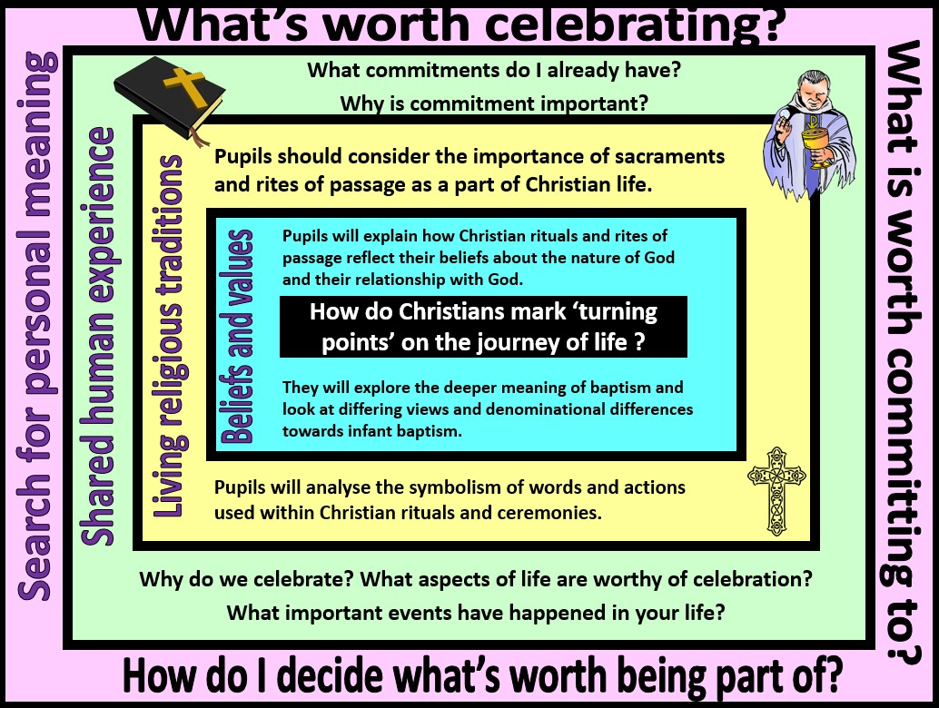

Focus Question: How do Christians mark the ‘turning points’ on the journey of life?
This unit enables pupils to explore the church as a community of believers and to examine how rites of passage reflect their commitment and relationship with God. The focus is on ‘is life like a journey’ so through this unit students will analyse beliefs, teachings and values and how they are linked by exploring the key sacraments in a Christian’s life. They should consider different dominations reflecting upon the importance of child baptism, confirmation and adult baptism. This can then be developed by students demonstrating a self-awareness of their own personal development by considering their own life journey and the changes they will make as they make as they progress through life.
Pupils should be able to apply their understanding of the Christian concept of God from previous years. They should be able to make meaningful links with Christian beliefs about God as ‘Father’, a God who became incarnate in order to teach and save, a God who is both transcendent and personal.
Field of Enquiry | Possible Teaching Ideas
Shared Human Experience  1 | - Draw a life chart in the form of a path and ask students to write down the changes that happen throughout life: born, start school, getting married etc.  - Draw a journey map and write in key celebrations or remembrance services you and your family have held. It could be birthdays, graduations, marriage a funeral etc.  - Consider why you have remembered or celebrated key events in your family. What was particularly important about these events?  - Discuss what commitments they have now and how they see these developing over time. Do commitments bring additional responsibilities? How might this help them in future life?

Beliefs and Values 2 | Read the story of the baptism of Jesus (Matthew 3:11-17). Identify important religious features of the story – the role of John the Baptist as a ‘voice in the wilderness’, the water, the voice of God, the dove. You may also want to watch a clip https://www.youtube.com/watch?v=9_dr9njVzKM  - Discuss ideas about why Jesus might have wanted to be baptised – if he is God incarnate then he must be without sin, so did he need to be baptised? What might the baptism of Jesus symbolise in his own life journey?  - Look at a range of art work depicting the baptism of Jesus. Ask pupils to choose their favourite and explain their choice. They should be able to use subject specific vocabulary and demonstrate an understanding of symbolism when talking or writing about their choice of art work.
Living | - Watch an infant baptism and ask students to think about/write around a picture the key parts of the service. Explain what we mean by the word promise, consider why making promises to God and the act of baptism may be important.  - Watch and compare with a believer’s baptism, focusing on the symbolism of the water washing away old life. http://www.cleo.net.uk/resources/displayframe.php?src=425/consultants_resources%2Freligiousedu c%2FstSbapt%2FstStephen.html  - Create a diary entry or photo story (with annotations) explaining the different services and why an infant baptism is different from an adult one. Discuss why Christians might have different views about when it is best for a person to be baptised.  - Discuss why a person may decide to get baptised in adult life? How does it show a person wants to commit to their faith? How would their life change?  - Give students words and pictures to link together symbolism and ask them to explain the meaning and purpose of the item: Water, white garment, candle, sin, vows etc.  - Explore how confirmation builds on the promises made at baptism and how it recognises the growth of a person’s Christian faith and commitment http://request.org.uk/life/rites-of- passage/confirmation-video/
Religious
Traditions
3
Search for | - Discuss what changes they might want to make to their life as they get older and how they would express this. What support and guidance might they need when if their commitments become difficult?  - Think about what new challenges, commitments and responsibilities they may face whilst growing up. What aspects of their future journey are they particularly looking forward to and why? How do they think they will mark these changes in their life?  - Discuss to what extent the phrase ‘life is like a journey’ is true.
Personal
Meaning
4

Y6 Learning - children will:
- Explain how rituals (sacraments/rites of passage) might reflect Christian beliefs about their relationship with God  - Explain how these rituals might differ between different denominations (eg. infant baptism and believer’s baptism) | * Analyse the importance of Christian rites of passage as an expression of faith and commitment  *Use religious vocabulary to explain the symbolism of words and actions used within rituals and ceremonies | - Discuss how people change during the course of their lifetime – and the key events that humans might mark on the journey of life  - Consider the value of celebrating landmarks in life – for individuals and communities | - Ask and respond thoughtfully to questions about how they have changed during their life so far – and how they might continue to change  - Discuss where they might find wisdom and guidance to help prepare them for the changes and responsibilities of different stages of life
Beliefs and values | Living religious traditions | Shared human experience | Search for personal meaning

