Year 6 Buddhism
Year 6 Key Question (to be used all year): Is life like a journey?
Focus Question (for this investigation): What do we mean by a ‘good’ life?

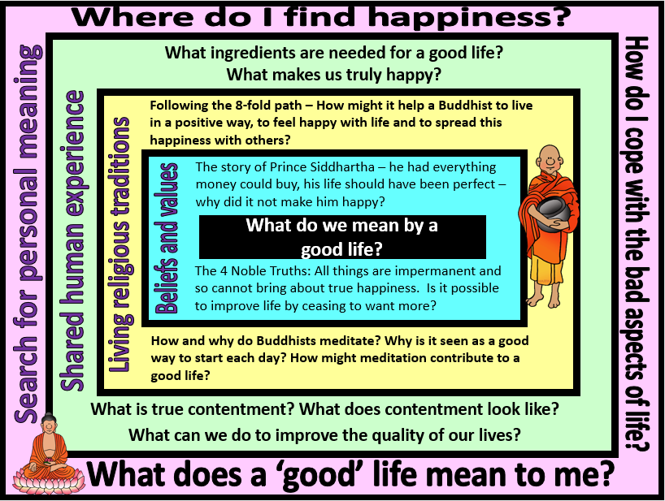

Focus Question: What do we mean by a ‘good’ life?
This unit will enable pupils to explore the concept of a good life through considering what Buddhism teaches makes someone truly happy. They will find out about the life experiences that started Prince Siddhartha’s journey to becoming the Buddha and will reflect on how the teachings of the Four Noble Truths and the Eightfold Path impact the spiritual journeys and daily lives of Buddhists. They will have the opportunity to experience meditation and to reflect on their own life and happiness as they prepare for the change of leaving primary school.
This unit will build on their prior learning about life as a journey and deepen their understanding of how people might cope with change and difficulties in life. They should be able to make reference to other religions and worldviews that they have studied when discussing how beliefs and values might give people guidance and support to enable them to live a ‘good’ life.
Field of Enquiry | Possible Teaching Ideas
Shared Human Experience  1 | - Research the meaning of the word ‘contentment’- – is it the same as happiness, or something different?  - Share the extract from Roald Dahl’s “Charlie and the Chocolate Factory” where Veruca Salt’s golden ticket is found or watch clip at https://www.youtube.com/watch?v=9_s-OrWz_Z8  - Discuss whether the children think that Veruca’s dad was being a good parent in the scene. Did getting the thing that Veruca said she really wanted make her happy? (A possible follow up activity in Guided Reading could be to read and analyse the extract of the factory tour where Veruca’s desire for one of Wonka’s squirrels leads to her demise.)  - Ask children to make a mind map of what they need to be happy. Give them time to reflect on their mind maps and colour code items into what is truly needed and those things which are actually something extra that they want. Have they included any values or rights? Why do they think people often want more rather than being satisfied with what they have? How does this desire for more affect our happiness?
Beliefs and Values  2 | - Share the story of Prince Siddhartha at https://www.bbc.co.uk/programmes/p010xtz3  - Pause at the point where Prince Siddhartha describes how, despite having everything he is not content. What had his father tried to protect him from? How had he done this? Was he being a good parent?  - Watch the end of the clip and identify the things that Prince Siddhartha saw on his journey that were new and challenging to him. Ask the children to reflect on what each experience taught Prince Siddhartha by writing his diary entry for the evening after his experiences.  - Find out about the Four Noble Truths. https://www.youtube.com/watch?v=TK-MbNj83NM and https://www.youtube.com/watch?v=bgcbQnL6-BQ are useful videos, but are challenging in places, so will need some discussion and explanation. This may also be helpful https://www.clear-vision.org/Schools/Students/Ages-12-14/Four-noble-truths.aspx
Living Religious Traditions  3 | - The fourth Noble Truth teaches that, in order to achieve virtue, happiness and eventually Nirvana, the Eightfold Path should be followed. Watch https://www.youtube.com/watch?v=RLS81XFzaWw  - Show a dharma wheel where the Eightfold Path is represented as a wheel with parts of the Path labelled as spokes. Discuss and match statements giving modern examples to the correct part of the path. Where does the Path lead a Buddhist? How does it help them to live in a positive way and share this happiness and contentment with others?  - The path of right concentration is sometimes translated as meditation. Meditation aims to still the mind so that the person doing it can become fully aware. Daily meditation is important for Buddhists in their aim of achieving nirvana and they often choose to start their day by meditating.  - Lead the children in some guided meditation. http://www.buddhanet.net/e-learning/buddhism/meditate/guide.htm provides ideas for a number of simple exercises that are suitable for the classroom.  - As a possible assessment activity, use the story and reflection questions at https://www.retoday.org.uk/media/display/110157.pdf
Search for Personal Meaning  4 | - Reflect on happiness. Is it something that we can control? Who or what affects our happiness?  - Ask the children to choose a shape or line to represent a path for their life as they prepare for the change of leaving primary school and starting secondary school. What challenges could there be that will affect their happiness? Who or what could help them to overcome these?  - Discuss what the phrase ‘A good life’ means to them now in the light of their exploration of this enquiry.

Y6 Learning - children will:
* analyse Buddhist beliefs and teachings about how to be content  * explain Buddhist beliefs and values contained within the story of Prince Siddhartha  * Make links between the story of the life of Prince Siddhartha and Buddhist beliefs and teachings about The Four Noble Truths | * describe and explain what is involved in following the Eight-Fold Path of Buddhism – and the impact that following this might have on the life of a Buddhist.  * consider the importance of daily meditation in Buddhism | * discuss the meaning of contentment – is it the same as happiness, or something different?  * raise questions about the human experience of being unsatisfied – why do humans so often want more than they have? To what extent does this prevent people from ever being happy? | * ask and respond thoughtfully to questions about their own happiness – consider this as something that they are in control of  * discuss the potential barriers to their happiness and what they can do to overcome these
Beliefs and values | Living religious traditions | Shared human experience | Search for personal meaning

