Year 6 Islam
Year 6 Key Question (to be used all year): Is life like a journey?
Focus Question (for this investigation): What is Hajj and why is it important to Muslims?

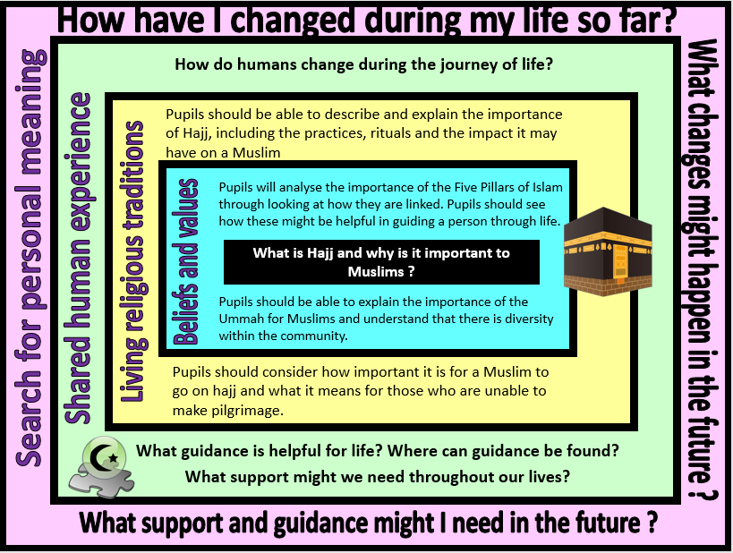
Focus Question: What is Hajj and why is it important to Muslims?
This unit enables pupils to explore the Five Pillars of Islam and how these beliefs and values impact on the life of a Muslim. Pupils should have opportunities to deepen their understanding by considering the pilgrimage to Mecca and completing Hajj. They should explore what is means to be a Hajji, reflecting on the personal journey a Muslim will make both physically and spiritually. They should be able to explain how a journey might change someone even after the journey itself is over.
Pupils will also consider their own life experiences and suggest how their lives have changed. They should consider the challenges that people may face during the journey of life and the support that may be needed as they move through their own life journey.
Field of Enquiry | Possible Teaching Ideas
Shared Human Experience  1 | - Make a list of achievements within the last 12 months. Pupils could bring certificates, pictures or write down what they have done. Discuss and reflect on how they achieved what they have - was it through being taught something new? Practice? Could they have done it two years ago? What has changed to allow them to develop their potential?  - Look at a range of people with different guidance roles (eg. police officer, teacher, mum, dad etc.) Ask pupils to think about the type of guidance they might gain from each about how to get through the journey of life.  - Discuss why humans might need the support of others during the journey of life.
Beliefs and Values  2 | - Give pupils a sheet with five squares and ask them to watch the religions of the world religions clip, as they watch as them to draw a picture to represents each pillar. (this programme is aimed at KS1 and pupils may have seen it before – this aspect of the lesson is to recap prior learning)  https://www.youtube.com/watch?v=H9U8T8x1AhQ  - Discuss how the Five Pillars link and how each pillar helps to support and guide a Muslim to live their life the correct way.  - Explore why the Ummah is important to Muslims and how Muslims can support each other in times of difficulty. (eg. during difficult times such as fasting (Sawm), the Ummah provide support as everyone else is also struggling it gives a feeling of community and togetherness). This can be developed by showing pupils pictures of Muslims from around the world, demonstrating unity in deiversity.  - KS2 BBC Bitesize Islam: https://www.bbc.com/bitesize/topics/zpdtsbk/resources/1
Living Religious Traditions  3 | - Pupils to watch clip from ‘My life, my religion’ about Hajj: https://www.bbc.co.uk/programmes/p02mwk0y  or ‘A trip to Mecca’ https://www.bbc.com/bitesize/clips/z9vcd2p  - Set up a ‘virtual Hajj’ around school. Talk through the importance of the rituals at each stage and how these both unite the community and strengthen personal faith. https://www.dropbox.com/s/ly9pp27gt649g7p/Reflection%20on%20Hajj.doc?dl=0  - Pupils to reflect on why it is important for a Muslim to complete hajj. Pupils could glue a picture of the Ka'ba in the middle of a page and write down all the feelings a Hajji may have around the outside.  - Deeper learning could explore the concept of intention and what it means for those unable to make the pilgrimage (the belief that they are still rewarded by Allah because with a pure heart they fully intended to go but restrictions such as financial or physical difficulties they were unable to.)  - Write a Hajj diary – including the experiences, emotions and personal reflections of a Hajji (this could be used as an assessment task)
Search for Personal Meaning  4 | - Pupils to make a journey map with photographs or pictures of their lives so far, plotting all the important events and achievements. Reflect on and talk about their journey and the people who have helped them – identifying why guidance and support is often necessary in life. Pupils to continue their journey map plotting out their hopes for the future and what help, support or guidance they will need along the way.  - Pupils could reflect on their journey through school and what they can do now that they once found challenging. What support did they receive to help them? How do they feel about the goals they have achieved?

Y6 Learning - children will:
* analyse the Five Pillars of Islam and how they are linked  * explain how the beliefs and values of Islam might guide a person through life  * explain the importance of the Ummah for Muslims and that this is a community of diverse members | * describe and explain the importance of Hajj, including the practices, rituals and impact  * explain how a person might change once becoming a hajji  consider how important it is for a Muslim to go on hajj – and what this means for those who are unable to make the pilgrimage | * discuss the various events that might happen on the journey of life and how people might change over the course of their life  * consider what support people might need on life’s journey | * ask and respond thoughtfully to questions about their own journey of life – consider how they have changed so far, how they will continue to change and the support and guidance that might be needed
Beliefs and values | Living religious traditions | Shared human experience | Search for personal meaning

