Year 5 Christianity - Jesus
Year 5 Key Question (to be used all year): Where can we find guidance about how to live our lives?
Focus Question (for this investigation): What do we mean by a miracle?

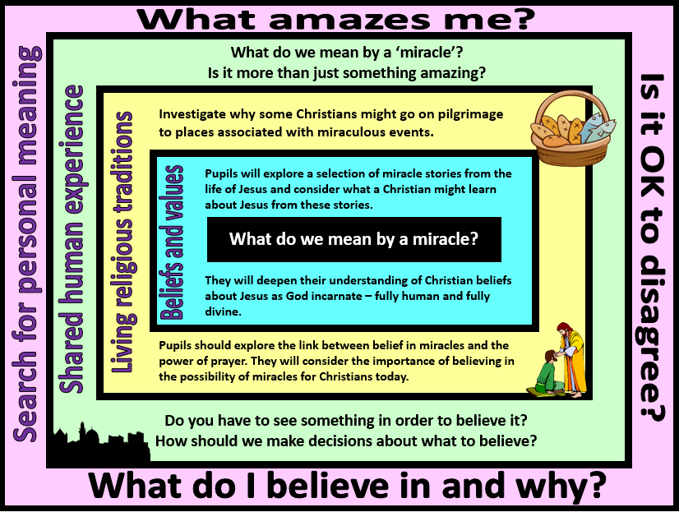
Focus Question: What do we mean by a miracle?
This unit enables pupils to explore what the Christian belief in Jesus as ‘fully human and fully divine’ means. They will build on their prior learning about the incarnation and to consider why some people regard the miracles of Jesus as signs of his divine nature. They might also reflect on what miracles such as healing the sick and feeding people reveal about the humanity of Jesus.
Pupils should have opportunities to discuss why some people believe in miracles and why others do not. In the context of Christianity, they should understand the importance for many Christians, of believing in the possibility of miracles and in belief in the resurrection of Jesus.
Pupils will investigate why some Christians might want to travel to a place associated with a miracle. They should reflect on the impact of bringing beliefs to life by standing in the place where an important event is believed to have happened. They should consider the meaning of the word faith and the experiences that might strengthen the faith of a believer.
Field of Enquiry | Possible Teaching Ideas
Shared Human Experience  1 | - Brain storm with the children ‘what is a miracle?’ Do you think you have ever witnessed a miracle? Write a class non-negotiable list to define a miracle.  - Find some real life events that have happened around the world, some that may be perceived as miracles, some not. Using the class list, ask pupils to categorise the events into Miracle/non-miracle.  - Show the video clip from the insurance advert https://www.youtube.com/watch?v=NZEFpTuK6Ks Ask pupils if we need to see something in order to believe it.  - Think of an ‘unbelievable’ scene you could act out at the beginning of the session e.g. eating an edible flower or chocolate buttons from a dog treats packet. At the end of the session explain the ‘magic’ and ask the children ‘Why did you believe me? Can you believe everything you do see? How should we decide who and what to believe?’
Beliefs and Values  2 | - Investigate miracles performed by Jesus (eg. feeding thousands of people, casting out evil spirits, healing the blind and sick, turning water to wine, controlling the water, catching a surprisingly large amount of fish, and raising people from the dead). Ask children to work in groups to read and then act out stories. Freeze frame the most significant moment in the story. Interview the characters to see what emotions they feel at that moment.  - Discuss what these stories tell us about what Christians believe about the nature of Jesus?  - What does it mean to be divine? Why do Christians believe that Jesus was divine? For Christians, how might the miracles of Jesus support their belief that he is God incarnate – fully human and fully divine?  - Possible assessment task: imagine you are a journalist, sent back in time to report on one of these events. Write an article/record a news report explaining what happened. Include interviews with eye-witnesses to explain the responses and thoughts that people might have had. Those working at greater depth could add an ‘editorial’ with their own thoughts and whether or not they think the miracle accounts prove that Jesus is divine.
Living Religious Traditions  3 | - Ask pupils if there are any places they would love to visit and why - e.g. the home place of someone special to them.  - Explain what we mean by pilgrimage and ask why Christians might want to go on a pilgrimage to the Holy Land – the land where Jesus was born and lived. Discuss what Christians might hope to see and do when they were there.  - Show video clips of pilgrimage to the holy land  https://request.org.uk/life/spirituality/pilgrimage  https://www.youtube.com/watch?v=yEtR2ouw76c  Explain that Christians believe that the ultimate miracle performed by Jesus was the resurrection – that the ability to rise from the dead three days after being crucified is proof that he was divine as only God has power over life and death.  - Discuss why a Christian might particularly want to go to Jerusalem at Easter time – how might a pilgrimage such as this bring to life the stories of the Bible? What impact might it have on a believer?
Search for Personal Meaning  4 | - Play a suitably adapted version of ‘I believe and I care about’ game with class https://www.uua.org/re/tapestry/children/welcome/session14/119826.shtml  The aim is for the children to see how different people believe different things, explain why we believe what we believe and knowing that everyone is different and not everyone has to agree with each other.  - Put pupils into 3 teams - provide each team with a different view on miracles:  - It did happen at the time of the Bible, but miracles don’t happen anymore.  - It can all be explained away by science, miracles do not happen.  - Miracles did happen in Biblical times, and still happen today.  Ask children to use their knowledge to prepare for a debate on belief in miracles from their given perspective. They should be able to use evidence to support their arguments. Make it clear that they are not arguing from their own point of view – the ability to be an advocate for a view other than your own is an important skill.  Hold a class debate – ‘Miracles are too impossible to believe in’

Y5 Learning - children will:
- describe Christian beliefs about miracles as ‘signs’ of the divinity of Jesus  - retell a selection of miracle stories – and explain what these might reveal to Christians about the nature of Jesus | - describe why some Christians might go on pilgrimage to places associated with miraculous events  - explain the impact that belief in miracles and the power of prayer might have on a Christian | - explain the difference between fact, opinion and belief  - consider differing interpretations of the word miracle – i.e. an amazing event, a very lucky experience, a strange coincidence, an act of God | - discuss their own beliefs – is there anything that they accept as truth which others may not agree with?  - reflect on how they make decisions about what is/is not true
Beliefs and values | Living religious traditions | Shared human experience | Search for personal meaning

