Year 4 Islam
Year 4 Key Question (to be used all year): How should we live our lives?
Focus Question (for this investigation): Why do Muslims fast during Ramadan?

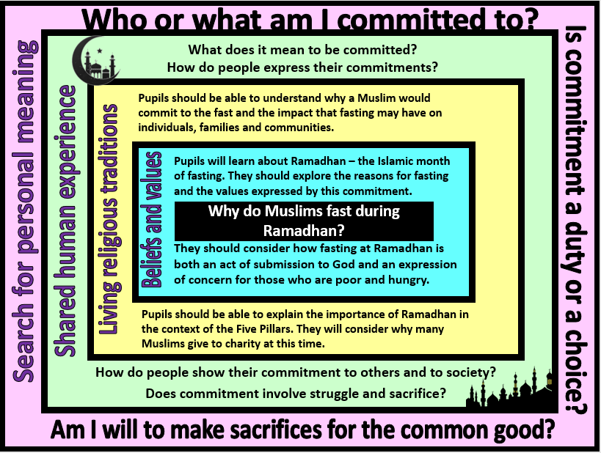
Focus Question: Why do Muslims fast during Ramadhan?
This unit enables pupils to examine the structures that underpin Islamic beliefs and practices in greater depth. Through a study of Ramadhan, opportunities are provided for pupils to understand the key values of Islam of submission to Allah and service to God through charitable life and actions. They will consider the role of commitment as part of religious life and reflect on the wider human value of being committed to ideas, to self-improvement or to other people. Pupils will have opportunities to think about their own commitments and the extent to which these have a positive impact on their lives.
Field of Enquiry | Possible Teaching Ideas
Shared Human Experience  1 | - Brainstorm the meaning of the word commitment. Discuss the value of showing commitment to a cause, to a community, to developing a skill, to a person etc.  - Ask pupils to discuss something that they would you like to be better at. What could you they do to improve this aspect of their life? How much time and effort would need to be focused on this in order to make a difference? What qualities might a person develop from being committed?
Beliefs and Values  2 | - Recap prior learning about Islam – Submission to Allah through upholding the Five Pillars (Shahada, Salah, Saum, Zakah, Hajj).  - Show a visual representation of the Five Pillars and explain that these are like foundations for the Islamic faith and way of life. Commitment is required to uphold the pillars. The Shahada is an ongoing commitment throughout life; Salah is commitment to the five daily prayers; Saum is the annual commitment to fast during the month of Ramadhan – along with Zakah, the commitment to sharing wealth; and Hajj is the once in a lifetime commitment to going on pilgrimage to Mecca.  - Show clips about Ramadhan https://www.youtube.com/watch?v=qFU9Cb0D6lo  https://www.bbc.co.uk/newsround/23286976  - Discuss Muslims fast during Ramadhan and the Islamic beliefs and values referred to in the clip. How might fasting at Ramadhan make Muslims more appreciative of their usual food and drink?  - Learn about the Night of Power and why this is a special day within Ramadhan. This is the night that Muhammad received his first revelation, and many Muslims spend this day praying and reciting the Quran.  https://www.retoday.org.uk/media/display/110133_Islam_Muhammad_Night_of_Power.pdf
Living Religious Traditions  3 | - Discuss what it would be like to give up food and drink during daylight hours. How much commitment would be required? Children could try giving up something, e.g. snack at break or talking for a specific amount of time. How did they feel watching other children eat or talk?  - Find out who is exempt from the fast. Discuss why these people are not obliged to take part.  - Look at images of Muslims breaking their fast. Discuss how it might feel to eat after a day of fasting. Why might it be important to share the Iftar? What impact might this have on individuals, families and the Islamic community?  - Role play/script a conversation between a Muslim and a non-Muslim, explaining about what Ramadhan is, why Muslims fast and the impact this has on a Muslim’s life (children may need to be encouraged to think about the spiritual benefits of fasting as well as the difficulties associated with fasting during Ramadhan in the UK). This could be used as an assessment activity.  - Investigate the celebrations involved with Eid al-Fitr. Discuss the feelings that a Muslim who has fasted may have at the end of Ramadhan and why they would want to celebrate this.
Search for Personal Meaning  4 | - Pupils should discuss their own values and commitments. Who or what are they committed to and how do they show this? Do they ever make sacrifices as part of their commitments? Would it ever be beneficial to do so? Is commitment part of a person’s duty or is it a choice?  - Debate the importance of commitment – create a continuum line to discuss the statement ‘It is important to totally commit to the things that matter’.  - Produce a visual display of the ‘Five pillars’ that support and uphold their lives. How do these pillars guide them in how they should live?
Y4 Learning - pupils will:
- explore Islamic teachings about Ramadan from the Qur’an  - make links between Islamic values and the beliefs explored so far in their study of Islam | - use subject specific language to describe how and why Muslims fast at Ramadan  - explain the importance of Ramadan in the context of the Five Pillars of Islam  - consider the impact that fasting might have on individuals, families and communities | - discuss (with relevant examples) the importance of showing commitment to a belief, value or community  - consider the role of sacrifice within religion and communities | - reflect on their own beliefs, values and commitments  - consider and discuss how they demonstrate their personal commitments
Beliefs and values | Living religious traditions | Shared human experience | Search for personal meaning

