Year 4 Sikh Dharam
Year 4 Key Question (to be used all year): How should we live our lives?
Focus Question (for this investigation): How do Sikhs express their beliefs and values?

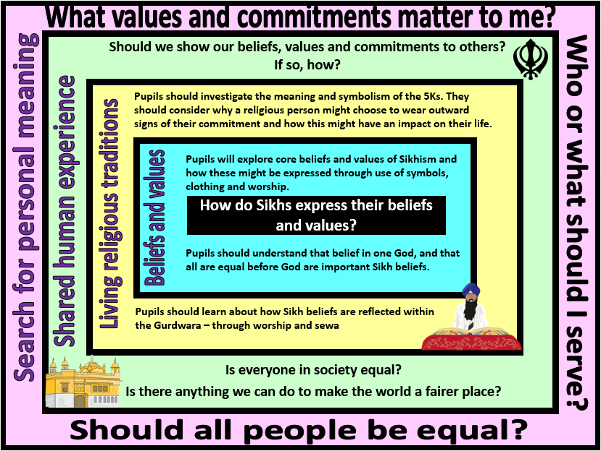
Focus Question: How do Sikhs express their beliefs and values?
This unit gives pupils the opportunity to explore how Sikhs convey their beliefs and commitments in the way they live their lives and through symbols which are observable expressions of faith. In their preaching and example, the Gurus revealed a way of life which was God centred. It is a life of religious, moral and social commitment. In outward and visible signs, Sikhs show themselves to be committed to following the teachings of the Gurus.
Sikhs are expected to demonstrate their commitment to their beliefs in the way they live their daily lives. Sikh belief perceives the world as the abode of God and as the place in which to practice Sikh dharam (religious, moral and social commitment). Sikhism teaches that all human beings should engage themselves in righteous actions and behaviour and work for a just social order.
Foremost amongst Sikh principles are:
• the complete equality of men and women everywhere;
• sewa: service to God, to the community of Sikhs and to the community at large;
• kirat karna: earning one’s living by one’s own efforts and by a livelihood which is honest;
• vand chakna: sharing one’s time, talents and earnings with the less fortunate.
How these influence the Sikh way of life will be explored within this unit.
Pupils should also have opportunities to reflect on important questions such as how humans show commitments to their values and communities, and issues of equality and justice.

Field of Enquiry | Possible Teaching Ideas
Shared Human Experience  1 | - Discuss the different ways that people might show their beliefs, values and commitments in public.  - Look at images of people wearing various uniforms and discuss how wearing that uniform might impact a person’s sense of identity and purpose. How might it also influence behaviour (consider the impact of being seen as a representative of a community rather than just as an individual)
Beliefs and Values  2 | - Re-cap the origins of Sikhism. Pupils should know who Guru Nanak was and why he is important to Sikhs. Watch the story of the blood and milk https://www.truetube.co.uk/film/blood-and-milk  and identify the Sikh beliefs and values that are demonstrated by the story. Discuss why belief in one creator God might lead people to want to treat all people as equals.  - Look at the Sikh symbol (the Khanda) and explain how it reflects Sikh beliefs and values in one eternal God and standing up for justice http://religious-symbols.net/sikh-symbols.html
Living Religious Traditions  3 | - Investigate the symbolism of the 5Ks that are worn by members of the Sikh Khalsa https://www.bbc.com/bitesize/clips/z3sb9j6  - Learn about the Gurdwara https://www.bbc.com/bitesize/clips/zd4wmp3  https://www.truetube.co.uk/film/charlie-and-blue-go-gurdwara  - Make links with what happens in the Gurdwara and the Sikh values of equality  - Learn about the Langar and why sharing food is an important part of Sikh hospitality and service (sewa). Explain that this concept extends out into the wider community and that many Gurdwaras are involved in projects to feed the homeless, support food banks and provide aid to those in need.  https://www.blogpreston.co.uk/2018/10/preston-sikh-community-to-feed-city-at-the-markets/  https://www.khalsaaid.org/  You could organise a visit to a Gurdwara or invite in a Sikh to talk to the class.
Search for Personal Meaning  4 | - Discuss the personal beliefs, values and commitments that they might want to express – and appropriate ways of doing this.  - Talk about the importance of seeing value in all people and how believing that all people are equal would have an impact on a person’s behaviour. Are the Sikh values of equality and justice good values to live your life by – should we be committed to these as human values?  - You could read ‘Have you filled a bucket today’ and discuss how small daily acts of kindness might be seen as a service to others. Create a class list of actions that could be done to fill the buckets of others.

Y4 Learning - children will:
* explore teachings and stories from Sikhism  * describe what moral guidance Sikhs might gain from the stories and examples of the Gurus  * make links between the beliefs, values and practices of Sikhism | * use subject specific language to describe how and why Sikhs show their religious commitments and values  * explain how clothing and behaviour might be symbolic of beliefs, values and commitments | * discuss (with relevant examples) the importance of how we view and behave towards others  * talk about how our outward behaviour reflects our inner beliefs, values and commitments | * reflect on their own concept of living a good life and how this influences the way that they treat others  * discuss own thoughts and feelings about equality and justice
Beliefs and values | Living religious traditions | Shared human experience | Search for personal meaning

