Year 3 Sikhism
Year 3 Key Question (to be used all year): Who should we follow?
Focus Question (for this investigation): Why are the Gurus important to Sikhs?

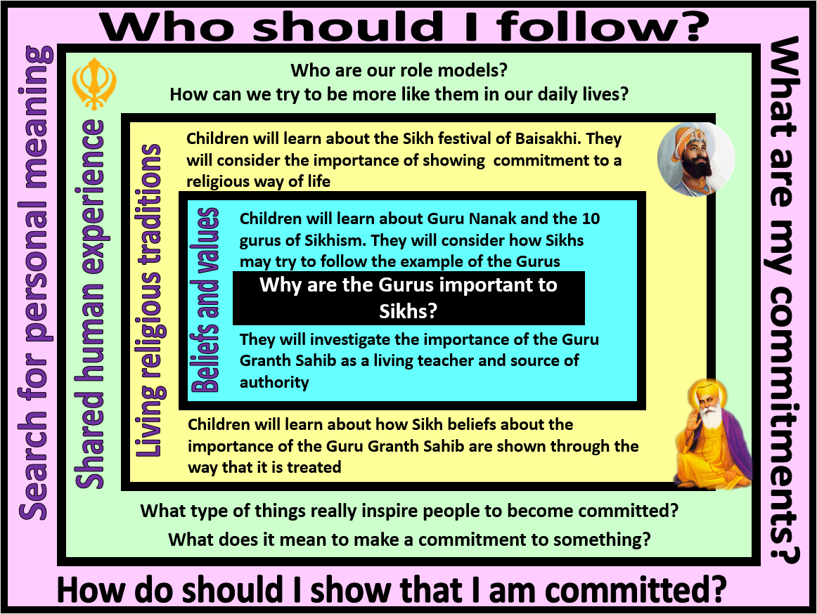
Focus Question: Why are the Gurus important to Sikhs?
This unit gives pupils the opportunity to explore the Sikh tradition and its origins with the teachings and example of Guru Nanak and Guru Gobind Singh. Pupils should consider the importance of commitment within Sikhism and how this might be expressed (they will explore these expressions in greater depth in Year 4).
Pupils should understand what is meant by the term ‘guru’ and why the gurus are important role models for Sikhs. They should learn about the Guru Granth Sahib and how/why it is treated with great respect by Sikhs and within the Gurdwara.
There should be a range of opportunities for pupils to reflect on and develop their own understanding of the value of commitment. They should consider how being committed can be both a challenge and a source of meaning and purpose.
Field of Enquiry | Possible Teaching Ideas
Shared Human Experience  1 | - Look at examples of famous sporting leaders. Create a list of the characteristics needed by such people – dedication, commitment, perseverance, determination, resilience, team players etc. Discuss why people like this are often seen as role models.  - Talk about people who are inspiring role models in contemporary society – how do they influence us? What type of things do we commit ourselves to because of the influence of such role models (eg. practising a sport, working hard to develop a particular talent, caring for the environment, helping others).
Beliefs and Values  2 | - Explain that the term guru means teacher – but not like a teacher at school. It is used to refer to people who teach wisdom, often religious teachers and leaders.  - Learn about the story of Guru Nanak https://www.youtube.com/watch?v=twkJ1pc5BvU  - Talk about the leadership and characteristics that Guru Nanak displayed that make him a role model for Sikhs.  - Pupils could produce a biographical profile of Guru Nanak’s life.  - After the death of Guru Nanak, a series of gurus led the community. The tenth Guru, Guru Gobind Singh, named his successor as the Guru Granth Sahib – the Sikh sacred scripture. Ask pupils to think about why a book might be viewed as a guru and what impact this might have on how the book is treated.
Living Religious Traditions  3 | - Ask pupils how they would prepare if a very important person was coming to stay with them – explain that the Guru Granth Sahib is treated as a VIP. Link this with the idea of showing commitment. Even though to a non-Sikh it might just be seen as a book, to a Sikh it should be treated as a living guru and so they are committed to treating it with the greatest respect.  - Explore how the Guru Granth Sahib is treated. Look at images of how it is kept inside the Gurdwara – if possible, visit a Gurdwara or invite a representative of the Sikh faith into school.  - https://www.youtube.com/watch?v=h2LbTwwGsAY  - Learn about the first Baisakhi and how it is celebrated by Sikhs. Discuss what a Sikh child might learn from the celebrations about the commitments involved in the Sikh faith. https://www.cbc.ca/kidscbc2/the-feed/whats-the-story-vaisakhi  https://www.youtube.com/watch?v=_fffDtJWUaM  - Consolidate learning – ask pupils to compile a list of the values and commitments that would be part of the Sikh way of life. They should be able to explain where these values and commitments come from: eg. Sikhs are committed to equality – this was demonstrated through the life of Guru Nanak and the example of Guru Gobind Singh. These could be used to script/role play an interview with a Sikh on the theme of commitment.
Search for Personal Meaning  4 | - Look at an image of a Sikh person and ask pupils to explain how the person publicly expresses their commitment to Sikhism. Discuss why religious people might want to show their commitment in a way that everyone can see. Talk about the fact that a person might need to have a strong faith and be quite brave to show their commitments in this way – and the importance of other people in society being respectful of this.  - Design a T-shirt that would show their own values and commitments.

Y3 Learning - children will:
* Develop an understanding of the importance of founders and leaders for religious communities  * Identify Sikh beliefs and values contained within the stories of the lives of the Gurus | * Describe how and why the Guru Granth Sahib is treated with great respect  * Suggest how and why Sikhs might show commitment to their faith | * Identify people and ideas that inspire commitment  *Discuss the different ways that people might show that they are committed | *Reflect on their own commitments and the impact that these have on their lives  *Ask questions about the value of having commitments
Beliefs and values | Living religious traditions | Shared human experience | Search for personal meaning

