Year 3 Christianity - Church
Year 3 Key Question (to be used all year): Who should we follow?
Focus Question (for this investigation): What do Christians mean by the Holy Spirit?

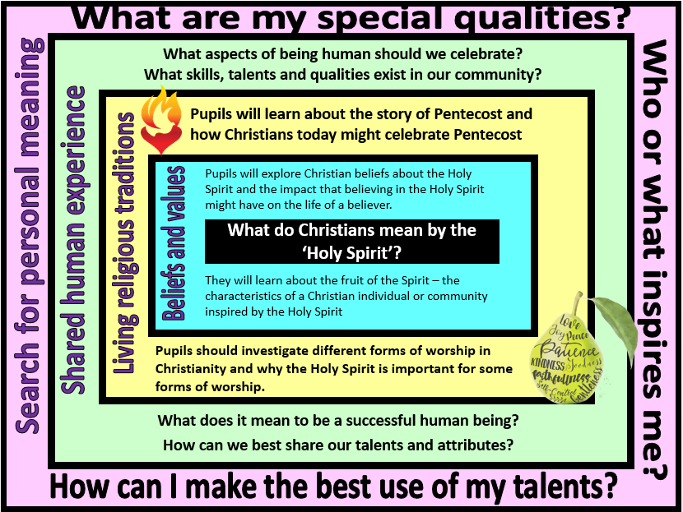
Focus Question: What do Christians mean by the Holy Spirit?
In this unit pupils will explore the Church as a community of people inspired by the Holy Spirit. This should build on their prior learning about the beliefs, values and symbols that unite the worldwide Christian community and the importance of worship. Pupils will learn about what Christians mean by the Holy Spirit and how this might inspire Christians to express their beliefs and values in different ways. There are also opportunities to explore how and why creative abilities such as music and art might be used to express ideas and talents.
Pupils should also reflect on their own unique skills/talents/qualities and how they use these. They should recognise that these ‘gifts’ are often inspired by someone or something.
Field of Enquiry | Possible Teaching Ideas
Shared Human Experience  1 | - Watch/listen to ‘What have you done today to make you feel proud?’ https://www.youtube.com/watch?v=LEoxGJ79PMs  - Talk about what it means to be a successful human? What different skills, talents and qualities might people have that they should be proud of?  - Pupils could talk about the things they have done or the things about themselves that make them feel proud.  - Write a class song to celebrate good things about the class
Beliefs and Values  2 | - Read/watch the story of the first Pentecost: https://www.youtube.com/watch?v=IqG_lvZhU-A  - Talk about why the flame might be a good symbol for the Holy Spirit. Light a candle and ask children to think about their feelings about the flame. Give each child a flame shape cut out of coloured paper and ask them to write a word to describe the flame/their feelings about the flame. Display flames and look at the collection of words generated. Ask children to identify which words might have applied to the apostles at the first Pentecost.  - Hot seating: Choose a pupil to take on the role of one of the apostles. Other pupils to ask questions to find out more about what happened at Pentecost and the impact that this might have had on the apostles and the early Christian community.  - Possible assessment activity: Imagine that you were one of the people present at the first Pentecost. What would you say to your family when you returned home?  - Explain that the fruit of the Spirit are qualities that Christian believes they can develop through the help of the Holy Spirit: love, joy, peace, longsuffering, kindness, goodness, faithfulness, gentleness, self-control. Christians are encouraged to develop these ‘good’ fruits of the spirit and to turn away from ‘bad fruits’. Ask pupils to suggest how these characteristics might inspire people to make a difference in the local community and/or globally.
Living Religious Traditions  3 | - Ask children to think about the lyrics of a Christian song such as ‘Colours of Day’ https://www.youtube.com/watch?v=mw-7CJhlbp0 and how it might link with what they have learned about the Holy Spirit. If your school subscribe to ‘Fischy music’ this is also a good example https://www.fischy.com/songs/bring-it-all-to-me-2/  - Explore differing forms of communal worship and the use of music in Christian worship  - Look at images of holy different Christian communities worshipping (eg. Pentecostal worship, Orthodox worship, Hillsong, Quaker meetings) – talk about how Christians might be inspired by the Holy Spirit in their holy worship. Ask children to think about why it might be important for Christians to believe that the Holy Spirit is present during worship. Discuss the fact that Christians might experience the Holy Spirit in different ways – link this to the idea that they had different ideas about the meaning of the flame.  - Give children some examples of church banners linked with the theme of the Holy Spirit/Pentecost. Explain that some Christian communities organise processions of witness at Pentecost (also known as Whitsuntide – and so the walks are referred to as whit walks) because they are proud to publicly show that they are a Christian. Design own banners including Christian symbols that might be seen at Pentecost. Once finished, write an explanation of the work.
Search for Personal Meaning  4 | - Give each child a cut-out shape of a person. Inside they should write/draw the qualities that they believe they should try to cultivate in themselves. Create a washing line of these across the class – the children can then compare their own values with those of others in the class.  - Ask children to take turns to stand up and tell the class something about themselves that they are proud of.  - Discuss who or what inspires them to be better people (these could be famous people or members of their family/community)

Y3 Learning - children will:
- know what Christians mean by the Holy Spirit  - suggest how belief in the Holy Spirit as God’s presence in the world might have an impact on individuals and communities  - identify Christian values exemplified in the gifts/fruits of the Spirit | - identify how beliefs about the Holy Spirit might influence forms of worship in a range of Christian denominations  - describe how and why Pentecost is celebrated  - describe why some Christians might take part in a procession of witness | - describe aspects of being human that we should be proud of  - discuss what it means to be a successful human – and the different measures of success that might be applied | - discuss their own sense of value and what is good/unique about being them  - reflect on the people that they value in their lives – and how they show their appreciation
Beliefs and values | Living religious traditions | Shared human experience | Search for personal meaning

