Year 1 Islam
Year 1 Key Question (to be used all year): What do people say about God?
Focus Question (for this investigation): How might beliefs about creation affect the way people treat the world?

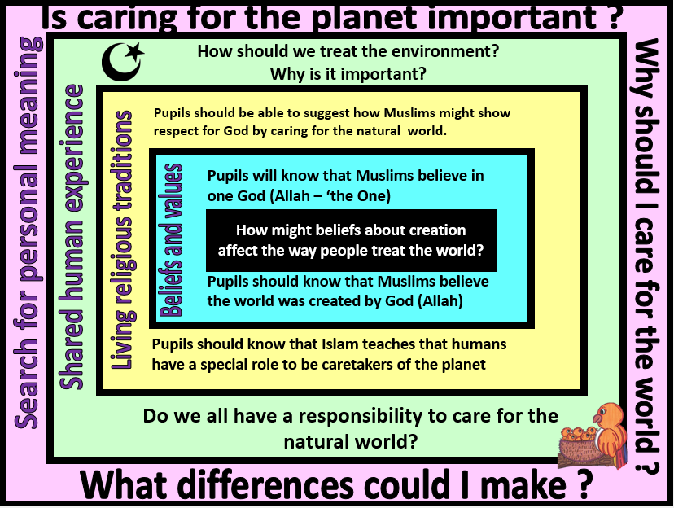
Focus Question: How might beliefs about creation affect the way people treat the world?
This unit enables pupils to examine the Muslim belief in Allah as creator. The focus is to encourage pupils to consider Allah’s role in creating and sustaining the world, and humankind’s response to Allah. Pupils should think about and reflect on their responsibility towards creation. They should begin to develop an understanding of how Muhammad (pbuh) is seen as a role model for Muslims and how the teachings of the Prophet might influence how and why a Muslim might care for the natural world. The experiences of the life of the prophet in this unit this should be explored through story. Pupils should have opportunities to discuss and demonstrate their understanding in a variety of ways. Pupils should also have opportunity to personally reflect on their own beliefs and values about the importance of caring for the natural world. They should consider their own responsibility and how they could actively contribute towards caring for the planet.
Field of Enquiry | Possible Teaching Ideas
Shared Human Experience  1 | - Pupils could go for a nature walk and talk about aspects of nature that they enjoy. They could collect leaves, acorns etc. and use these to make a collage or print picture. These could be used as a display of the natural world to prompt discussion.  - Show pupils a variety of environmental pictures good and bad and ask them to discuss what is happening in the pictures. Development of this task could be to ask students who they think is responsible for taking care of the world and why they think people should care about the world. They could also watch the Wonderful world song and think about of all the wondrous things in the world and why it important they are cared for: rainforests, flowers, oceans etc.  https://www.youtube.com/watch?v=m5TwT69i1lU
Beliefs and Values  2 | - Watch the BBCTeach clip of Islamic stories. Talk about the stories with the children – ask them to think about why Muslims might think that it is important to teach children to care for all living things. Encourage them to connect the belief in one God who create the world with the view that living things should be cared for  https://www.youtube.com/watch?v=_bN7KIMmwlc  Read the Islamic story of the Baby birds ( teaching from the life of Prophet Muhammad pbuh) book/puppet set available https://www.articlesoffaith.co.uk/faiths/islam.html?limit=all  Ask pupils to think about why the Prophet Muhammad might be seen as a good role model by Muslims.
Living Religious Traditions  3 | - Discuss what it means to be a ‘caretaker’ – you could ask your school caretaker to come in and speak to the class about what their job involves and how this role supports the life of the school.  - You could introduce the word Khalifah and explain that it is the Muslim word for being a caretaker of the world. Discuss how this would affect the way a Muslim might behave – what things might people do differently if they believed that caring for the plane was an important part of their religion?  - Look at images of environmental issues (eg. pollution, rubbish being dumped, plastics in the oceans) and ask pupils to suggest why a Muslim might be concerned about these issues and what they might want to do as a result of their concern.
Search for Personal Meaning  4 | - Pupils to write down rules they think they should follow in order to make the environment better in their home/school/local community  - Pupils could paint an picture to show their own beliefs and values about how the natural world should be  - Pupils to talk about what is important to them in the natural world? What would they do to improve it? Why?

Y1 Learning - children will:
* know that Muslims believe in one God (Allah)  *know that Muslims believe the world was created by God  *Talk about why Muslims might value the natural world | * know that Islam teaches that humans should be caretakers (stewards/Khalifahs) of the planet  *Suggest how Muslims might show respect for God by caring for the natural world | * Talk about their own experiences and feelings about the natural world and what they have noticed about the way that humans treat it | * Reflect on how they treat the natural world – and if they have a duty to look after it
Beliefs and values | Living religious traditions | Shared human experience | Search for personal meaning

