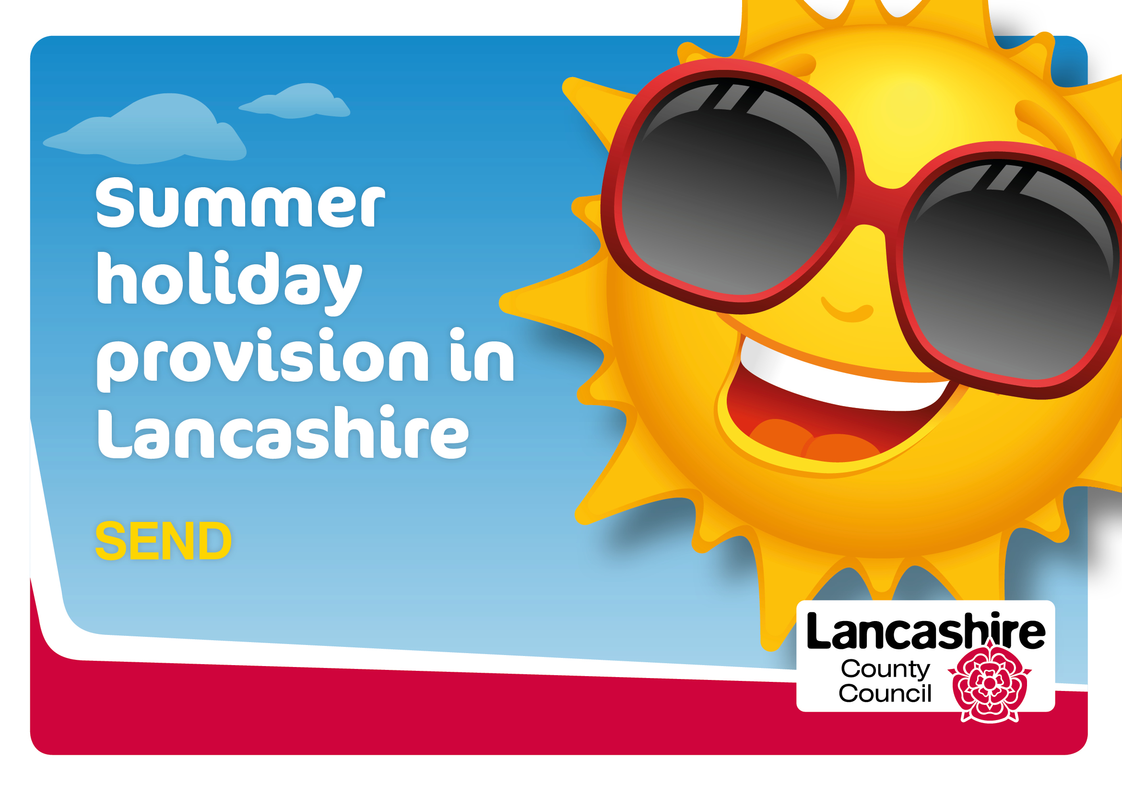
District | Organisation providing activity | Dates of Activity | Details of Activity | Age group | Referral required Y or N | Referral criteria | Cost | Contact details/ how to book
All Districts | Lancashire SEND Partnership | Throughout Summer | The Summer issue of the FIND Newsletter is packed full of ideas to help families during the Summer, with learning resources from the Specialist Teacher Service, online support groups, zoom dance classes, webinars and more  . | All ages | N | N/A | Free | https://www.lancashire.gov.uk/children-education-families/special-educational-needs-and-disabilities/  If you would like to receive a free copy of FIND by post or email 4 times a year, please sign up to the Family Information Network Directory (FIND) database.
All Districts | Lancashire SEND Partnership | All Year | Accessible and inclusive activities, things to do and places to go. | All ages | N | N/A | Prices vary | https://www.lancashire.gov.uk/children-education-families/special-educational-needs-and-disabilities/things-to-do/accessible-and-inclusive-activities/
All Districts | ABLEise | All Year | Disabled Support Groups Clubs and Organisations in Lancashire  ABLEize offers details of a whole range of Lancashire based disabled and special needs information, services, clubs and groups websites offering social activities, sports, disabled care, education and activities. | All ages | N | N/A | Prices vary | https://www.ableize.com/disabled-groups-and-clubs-by-county/lancashire/
Fylde and Wyre | UR Potential | Tuesdays  4:00-6:00pm | Art Group—Keeping in contact through messages and phone calls.  Getting involved in social media tasks, quizzes and art work at home  Weekly online art sessions, Google Meet online platform | 11-18 years (up to 25 years for young people with SEND) | N | N/A | Free | Contact April if you require more information::  april@urpotential.co.uk/ 07411062086  Follow us on our social media pages : Facebook, Twitter, Instagram  @urpotentialuk  @blackpoolyc
Hyndburn,  Rossendale &  Ribble Valley | Children & Family Wellbeing Service | Thursday's  7-8PM | SNAP (SEND)  This virtual group is for young people aged 12- 25 years with special educational needs and disabilities. This group welcomes teenagers and supports them to build their confidence and self-esteem, develop life skills and independence as well as helping with social/ communication skills. No booking necessary. Parents and carers are welcome to attend. | 12-25 years | N | N/A | Free | To take part in any of our virtual groups and courses you will need a Zoom account and an email address. You will need to set this account up prior to accessing the group. Once we have spoken to you, we will email you an invite into the group. Please be assured we have lots of systems in place to safeguard you and your children.
Burnley | Children & Family Wellbeing Service | Every Thursday | SEND 5-11 years session for parents with a child who has a special educational need and/or disability | Children aged 5-11 years and parents | N | N/A | Free | https://www.facebook.com/BurnleyFamilyZone/
Pendle  Burnley | Children & Family Wellbeing Service | Every Tuesday 7-8-30pm | SEN Group. This group welcomes teenagers and supports them to build their confidence and self-esteem, develop life skills and independence as well as helping with social/ communication skills. No booking necessary. Parents and carers are welcome to attend. | 12-25 years | N | N/A | Free | Contact : Mohammed.Arshad@lancashire.gov.uk  Or via Talkzone service who can be can be accessed via;  - Telephone: 0800 51 11 11  - Text: 07786 51 11 11  - Email: talkzone@lancashire.gov.uk  - Talk on-line in a private and confidential space by logging onto: http://www.lancashire.gov.uk/youthzone
Rossendale | Children & Family Wellbeing Service | Tuesday  7pm-8pm  1hour weekly sessions  Ongoing | Bacup Youth Group- Issue Based Youth Work- an opportunity to meet and integrate with other young people in a safe environment. Access a variety of fun, positive activities including virtual, sports and team activities. Opportunities to discuss current issues that may be affecting the lives of young people. Help increase confidence and support, individuals health and wellbeing | 12 – 19 years, up to 25 with SEND | N | N/A | Free | To take part in any of our virtual groups and courses you will need a Zoom account and an email address. You will need to set this account up prior to accessing the group. Once we have spoken to you, we will email you an invite into the group. Please be assured we have lots of systems in place to safeguard you and your children.  01706 237780 Bacup & Whitworth
Rossendale  Hyndburn  Ribble Valley | Children & Family Wellbeing Service | Wednesday  6.45pm-7.45pm  1 hour weekly sessions  Ongoing | Youth Group- locality offer  Issue Based Youth Work - an opportunity to meet and integrate with other young people in a safe environment. Access a variety of fun, positive activities including virtual, sports and team activities. Opportunities to discuss current issues that may be affecting the lives of young people. Help increase confidence and support, individuals health and wellbeing. | 12 – 19 years, up to 25 with SEND | N | N/A | Free | To take part in any of our virtual groups and courses you will need a Zoom account and an email address. You will need to set this account up prior to accessing the group. Once we have spoken to you, we will email you an invite into the group. Please be assured we have lots of systems in place to safeguard you and your children.  01706 237780 Bacup & Whitworth  01706 237782 Haslingden  01706 237788 Rawtenstall
Rossendale | Children & Family Wellbeing Service | Thursday 7pm-8pm  1hour weekly sessions  Ongoing | Stars – providing a safe and welcoming environment for young people aged (12 – 25 years) with special educational needs and disabilities. The group aims to work on life skills, improving communication skills, self-confidence & self-esteem in a group work setting. Parents/Carers are welcome to attend. | 12 – 19 years, up to 25 with SEND | N | N/A | Free | To take part in any of our virtual groups and courses you will need a Zoom account and an email address. You will need to set this account up prior to accessing the group. Once we have spoken to you, we will email you an invite into the group. Please be assured we have lots of systems in place to safeguard you and your children.  01706 237780 Bacup & Whitworth  01706 237782 Haslingden  01706 237788 Rawtenstall
Lancaster | Children & Family Wellbeing Service | Monday  3.30 - 4.30 | AOK Juniors  A parent peer support group providing a safe and welcoming environment for children with any additional needs and their parents/carers to enjoy a variety of activities and meet new friends. Siblings welcomed too. | 5-11 years | Y | Children with additional needs | Free | Please contact claire.rogerson@lancashire.gov.uk
Lancaster | Children & Family Wellbeing Service | Wednesday  1.00 – 1.30 | AOK  A parent peer support group providing a safe and welcoming environment for children with any additional needs and their parents/carers to enjoy a variety of activities and meet new friends. Siblings welcomed too. | 4-5 years | Y | Children with additional needs | Free | Please contact claire.rogerson@lancashire.gov.uk
Lancaster | Children & Family Wellbeing Service | Wednesday  6.30 – 7.30 | AOK  A parent peer support group providing a safe and welcoming environment for children with any additional needs and their parents/carers to enjoy a variety of activities and meet new friends. Siblings welcomed too. | 12+ years | Y | Children with additional needs | Free | Please contact claire.rogerson@lancashire.gov.uk
Lancaster | Ludus Dance | Wednesday  2.00-2.45 | Inclusion in Motion  A creative, sensory dance programme for children with additional needs. | 6-12 years | Y | Children with additional needs | Pay what you feel | https://www.eventbrite.co.uk/e/inclusion-in-motion-tickets-102892807156
West Lancashire | Twinkle House | All Year | Twinkle House is a Registered Charity providing free support sessions for children and young people with Disabilities and Additional Needs 0-19 years. Our priority area for children’s support is West Lancashire. We also provide a range of sensory rooms and Hydrotherapy Pool available for all ages and abilities | 0-19 years | N | N/A | Free | http://www.twinklehouse.co.uk/  Enquiries@twinklehouse.co.uk
Ribble Valley | Children & Family Wellbeing Service | Monday  7:30pm-8:30pm | PHAB - inspires and supports children, young people and adults with and without disabilities to make more of life together– breaking down community barriers, reducing social isolation, and creating opportunities for disabled people to enjoy the same activities and challenge as, and alongside, those without a disability. | 0-19 years | N/A | N/A | Free | Physically Disabled and Able Bodied (PHAB)  To take part in any of our virtual groups and courses you will need a Zoom account and an email address. You will need to set this account up prior to accessing the group. Once we have spoken to you, we will email you an invite into the group. Please be assured we have lots of systems in place to safeguard you and your children.  The Zone Clitheroe  Wesleyan Row  Clitheroe  BB7 2JY  Tel: 01200 420460  Longridge Young People’s Centre  Berry Lane  Longridge  PR3 3JP  Tel: 01772 538978

