What is bullying?

In our school a bully is someone who hurts someone more than once, deliberately using behaviour which is meant to hurt, frighten or upset another person.

Bullying can be…
Emotional: Hurting people's feelings, leaving you out, making you feel bad.
Physical: Punching, kicking, spitting, pushing, theft.
Verbal: Being teased, name calling, being rude.
Racist: Calling you racist names, graffiti.
Online: Saying unkind things by text, email, social media.

When is it bullying?
Several Times On Purpose

Remember some things you say to someone may be said to try and be funny but it may be hurtful to that person. Think before you speak!

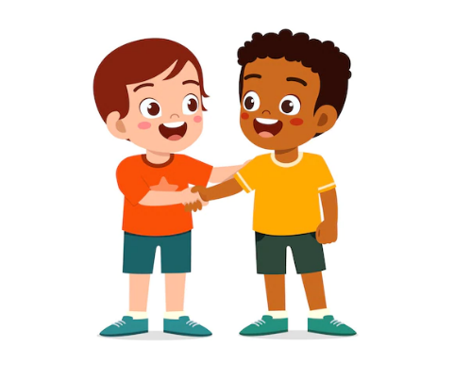
Who can I tell if I think this happening to me?
- A friend
- A family member
- Member of School Council
- Any teacher at school or any adult in school
- Someone you trust
- Anybody near you

MOST IMPORTANTLY If you feel you are being bullied :

Start Telling Other People

If you are bullied:

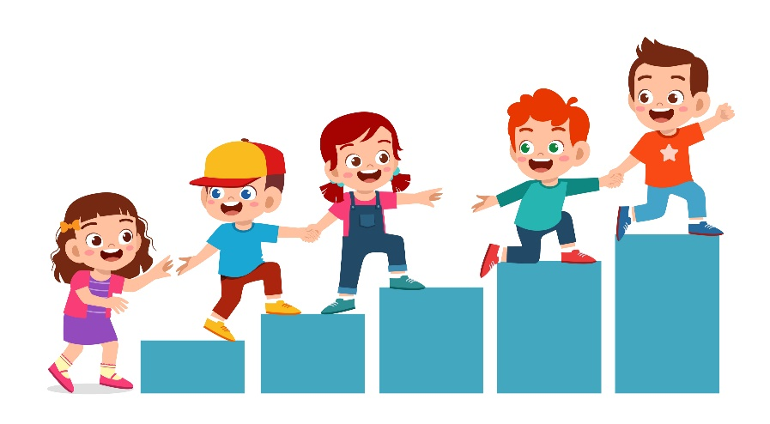
Do
- Ask them to stop if you can.
- Use eye contact and say stop
- Ignore them.
- Walk away.
- TELL SOMEONE!

DON’T
- Do what they say.
- Get angry.
- Hit them.
- Think that it is your fault.
- Do not retaliate.
- Hide it.

What should I do if I see someone else being bullied?

- Don’t walk away and ignore the bullying.
- Tell the bully to stop if it is safe to do so.
- Don’t stay silent or the bullying will keep happening.
- Don’t lose your temper.
- DO TELL SOMEONE.

The Head Teacher, Governors, Staff and Pupil Parliment will work together to:
- Make our school a place where everyone can feel happy. That means no bullying allowed.
- We will help everyone to get on with each other and we believe that everyone has the right to feel safe and be themselves.

