Year 6 Christianity - Jesus
Year6 Key Question (to be used all year): Is life like a journey?
Focus Question (for this investigation): Why do Christians believe Good Friday is good?

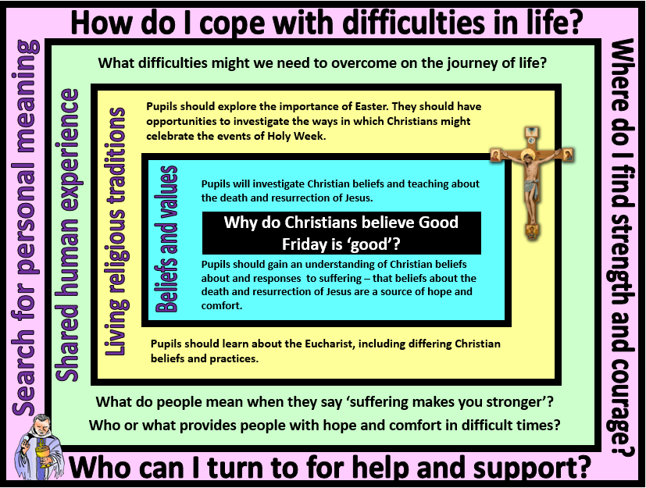
Focus Question: Why do Christians believe Good Friday is good?
This unit enables pupils to explore the events of Holy Week and Easter Sunday in the Christian religion. This builds on their prior knowledge of Lent, the Easter Story and the concept of Jesus’ sacrifice. They will focus on Christian beliefs about suffering and how these are responded to and commemorated through the events of Holy Week. Through study of Eucharist in different denominations, pupils will identify how Christians view the death and resurrection of Jesus as a source of guidance and comfort. They should have opportunities to reflect on whether suffering can make a person stronger and who or what they can turn to when facing difficulties.
Field of Enquiry | Possible Teaching Ideas
Shared Human Experience  1 | - Take pupils to a large space, such as the school hall or playground. Give them each a piece of A3 paper/card each and ask them to stand on it at one end of the space. The challenge is to get from where they are to the other side of the space without stepping off a piece of paper. They should quickly realise that completing the challenge alone is impossible - it can only be completed by teaming up with others for help and support.  - Ensure that pupils understand what is meant by the terms guide, comfort, strength, suffering, struggle and courage. How were these present in the challenge?  - Ask pupils to think about any difficulties that they have faced as they have grown up and matured. Who have they turned to for help and support?
Beliefs and Values  2 | - Watch the Lego Easter Story at https://www.youtube.com/watch?v=-M8Yesnt1V8 . Watch again and pause at various points to use ‘I see/I think/I wonder’ prompts to explore what children’s ideas and responses to what is happening.  - Identify points where suffering took place in the story. Hot seat children as people involved in the events and discuss their thoughts, feelings and motives.  - Show a selection of simple props or images linked to Holy Week events (such as a bread roll, a wash cloth etc). Ask pupils to identify which event each item or image is linked to and sequence them to create a Holy Week timeline that can be displayed in the classroom.  - Use the display as support for the children retelling the events leading up to and including the death of Jesus by writing in role as one of the disciples or as Jesus.  - Discuss how these beliefs might guide and comfort a Christian during difficult times in their own lives.
Living Religious Traditions  3 | - Watch ‘My Religion, My Life: Christianity’ https://www.youtube.com/watch?v=MK2o-mhBfuc . Identify what events leading up to Jesus’ death are being commemorated and how this is done.  - Watch the section of the video again that focuses on the Eucharist and explore what happens at a Eucharist celebration. Talk about what this is and the important part that it plays in the life of a Christian. What differences did the pupils notice between the celebrations of Christians from different denominations  - A good opportunity would be to visit a church to witness a Eucharist celebration or interview a Christian about the Eucharist (this could be done through use of the ‘email a believer’ resource http://pof.reonline.org.uk/wordpress/?page_id=19)  - Traditionally celebrations are of joyous events. Discuss why a Christian chooses to celebrate the events leading up to Jesus’ death. Return to focus question for the investigation and create mind map with the pupils about how Good Friday could be called ‘good’.  - Possible assessment task: give pupils four images lined to Easter: a collection of chocolate eggs; the empty tomb; the cross at Golgotha and the bread and wine from Eucharist. Pupils explain the Christian beliefs and traditions represented by each image. What is the connection between the images? If you were asked which picture is the odd one out, which one would you choose and why?
Search for Personal Meaning  4 | - Pupils to make a personal set of Stations of the Cross showing challenges from their journey of life or through school so far in images and words.  - Reflect on who or what has given them guidance and comfort at difficult points.  - Hold a debate: The house believes that suffering makes you stronger. Divide class into two groups to argue for or against. Hold a vote on the motion.

Y6 Learning - children will:
- retell the events leading up to and including the death of Jesus  - explain how beliefs about the suffering, death and resurrection of Jesus might guide and comfort a Christian during difficult times in their own life | - explain how and why Christian individuals and communities might celebrate the events of Holy Week  - use religious vocabulary to describe and explain the Eucharist  - explain different Christian beliefs about the Eucharist and its importance | - consider how people might mature and become stronger through overcoming difficulties  - consider the value of being part of a community on the ‘journey of life’ | - raise questions and discuss the extent to which they agree that ‘suffering makes you stronger’  - discuss own experiences and attitudes towards the importance of having companionship on the journey of life
Beliefs and values | Living religious traditions | Shared human experience | Search for personal meaning

