Year 6 Hindu dharma
Year 6 Key Question (to be used all year): Is life like a journey?
Focus Question (for this investigation): Is there one journey or many?

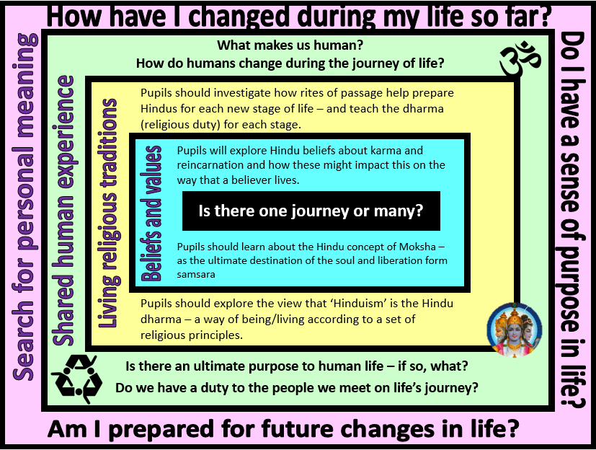

Focus Question: Is there one journey or many? What do Hindus believe about the cycle of life, death and rebirth?
This unit enables pupils to explore Hindu beliefs about reincarnation and consider how these beliefs might impact on a Hindu’s view about the purpose of human existence. Pupils should be able to build in their prior learning about the concept of ‘dharma’ within Hinduism. They should develop an understanding of the belief that dharma can change during the course of life and that the religious duties of a child are seen as different to those of an adult with family responsibilities or an elderly person. They should be able to explain how performing dharma would have an impact on a person’s karma – and how this then links with Hindu beliefs about the cycle of life, death and rebirth.
Pupils should have opportunities to explore Hindu beliefs about reincarnation of the soul and the ultimate aim of Moksha (liberation from rebirth).

Field of Enquiry | Possible Teaching Ideas
Shared Human Experience  1 | - Pupils could bring in a photograph of themselves as a baby/toddler – class could try to guess who each photo is of and talk about what has changed/what has stayed the same about each person  - Look at images of elderly people and discuss thoughts and feeling about the fact that getting old and eventually dying is part of the human experience. As a class, list beliefs and ideas that people might have about the purpose of human life
Beliefs and Values  2 | - Explore Hindu beliefs about the cycle of samsara – the view that the soul (the atman) is in a continuous flow of life, death and rebirth – with an eventual aim of reaching Moksha (freedom from samsara)  - Watch ‘My religion, my life: Hinduism’ clip about belief in reincarnation https://www.youtube.com/watch?v=Uq6_HUMtQtI  - Discuss how belief in the law of karma and the process of samsara might affect a Hindu’s sense of purpose in life  - Pupils could design a ‘Game of Life’ using a snakes and ladders board layout. Pupils could add own suggested positive/negative actions to the bottom of ladders/top of snakes.
Living Religious Traditions  3 | - Learn about the four ashramas – the four stages of life in Hindu tradition  - Investigate how Hindus mark important stages in life (the 16 samskaras).  - Focus on the Sacred Thread ceremony (the Upanayana) which celebrates the child being seen as responsible enough to take on religious duties. https://www.bbc.com/bitesize/clips/zmmgkqt  - Discuss how the ceremony might help the Hindu child to understand the role and duties of the brahmacharya stage.
Search for Personal Meaning  4 | - Plan a ceremony that could be used to mark and celebrate the transition from primary school to secondary – think about what they have learnt from the Sacred Thread ceremony (eg. acknowledging and showing gratitude to the people who have helped on life’s journey so far, making a declaration of commitment to the next stage of life, symbolic actions to demonstrate readiness for the new responsibilities and independence)  - Discuss whether or not pupils think it is helpful to have special ceremonies to mark transition points in life. Is it the end of one stage or the beginning of a new one that is celebrated? Is the next stage of life really a fresh start or simply the continuance of a journey?

Y6 Learning - children will:
* analyse Hindu beliefs about samsara, karma and moksha and how these are linked  * explain how belief in reincarnation might affect the way in which a Hindu views the ‘journey of life’  * explain how belief in reincarnation and the law of karma might affect the way a Hindu lives | * describe and explain the four ashramas (stages of life) in the life of a Hindu  * explain how a person might change as they move from one ashrama to the next  * consider the importance of the samskaras (rites of passage) in preparing a Hindu for the commitments of each ashrama | * discuss the special milestones that we might celebrate during a person’s lifetime  * discuss how our rights, responsibilities and relationships with others might change as we go through life | * ask and respond thoughtfully to questions about their own journey of life  * consider how events and influences so far have made them the person they are today and what has been important learning to prepare them for the future
Beliefs and values | Living religious traditions | Shared human experience | Search for personal meaning

