Year 6 Christianity - Church
Year6 Key Question (to be used all year): Is life like a journey?
Focus Question (for this investigation): If life is like a journey, what’s the destination?

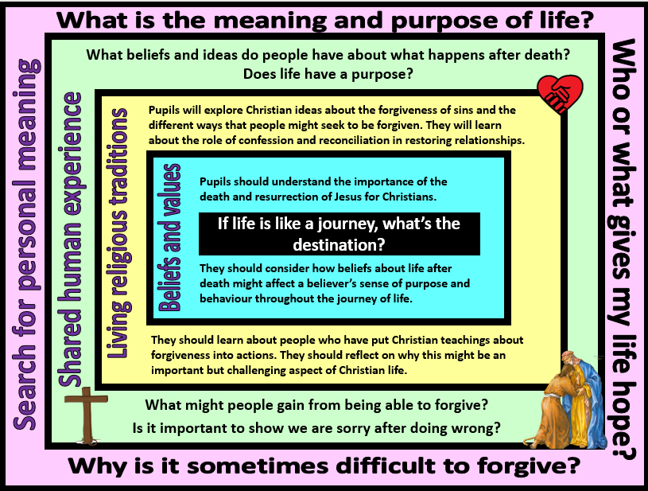
Focus Question: If life is like a journey, what’s the destination?
This unit enables pupils to explore what it is that Christians believe gives their lives purpose and meaning. This builds on their prior learning about how Christians are guided to live. Pupils will learn about the effect that belief in salvation brought about by Jesus’ death and resurrection has. They will discover how the act of confessing sins and seeking reconciliation and forgiveness restores relationships with others and with God in the eyes of the believer, leading to faith in life after death. Pupils should have opportunities to reflect on the importance of forgiveness to them.
Field of Enquiry | Possible Teaching Ideas
Shared Human Experience  1 | - Put pupils into groups and give each a large sheet of paper with one of these questions: What sort of things are we sorry for? Why do we say sorry? Why is it important to say sorry? Give them time to discuss their question and note any ideas onto the sheet. After a few minutes, pass sheets around so that each group receives a question with some ideas already noted. They can read what the previous group’s responses were and add other ideas that they may have. Continue until all questions have been considered by each group. Display the responses and discuss.  - Place numbers 0-10 in the centre of the classroom/hall. Explain that this is a forgiveness scale where 0 represents something that can be forgiven easily and instantly and 10 is something unforgivable. Share some scenarios. After each, pupils place themselves on the scale according to how challenging that scenario would be to forgive. Any position is acceptable as long as they can explain why they have placed themselves there.  - What is ‘purpose’? Explore together how different people that the pupils are familiar with may feel that they have different purposes to their lives. Have the personal beliefs of any of these people influenced the way that they live their lives and the relationships that they have?  - What do people believe happens after death? How might this affect their sense of purpose?
Beliefs and Values  2 | - Christians believe that Jesus died to pay for their sins and to restore the close relationship with God that humans were damaging with their wrong choices and behaviour (known as sin). Three days after the crucifixion, Christians believe that God raised Jesus back to life (known as the resurrection), showing that Jesus’ death was a victory over sin and death. They feel that they were saved and so the belief is known as salvation.  - Christians know that physical death still happens, however, Christian teachings state that those who believe in God and live good lives will be given eternal life in Heaven after their physical life is over. Christians believe that after death they will be taken into the presence of God and they will be judged for actions that they have done or failed to do during their lifetime. In St John’s Gospel it says that, “God so loved the world that he gave his one and only Son, that whoever believes in him shall not perish but have eternal life.(John 3:16), whilst Jesus is quoted as saying, “I am the resurrection and the life. He who believes in me will live, even though he dies. (John 11:25-26)  - Ask pupils to reflect on how this belief in life after death would affect the decisions that a Christian may make and their sense of purpose throughout their journey of life.
Living Religious Traditions  3 | - Because of their belief in life after death, Christians try to atone (make amends for) their sins. They believe that if they repent (are truly sorry for/turn away from) their sins and confess what they have done wrong, they will receive forgiveness them which will lead to them entering Heaven. Watch https://www.youtube.com/watch?v=V-YuMPnbVHw where some children explain what confession is and why Christians confess their sins.  - Catholic Christians now refer to confession as reconciliation. Explore the meaning of the word and discuss why the pupils think it is used.  - Share https://reconciliationeducation.weebly.com/the-four-steps.html where the four steps of the sacrament of reconciliation are explained. Watch https://www.youtube.com/watch?v=fXLiyY6II6Q where the sacrament is demonstrated (note: these are role plays only). As a possible assessment task, ask the pupils to identify each of the stages and how they are shown.  - Return to the forgiveness scale. Share the scenario, “You teach about love, fairness and respect. This annoys the people who are in charge. They nail you to a cross and leave you to die.” After some discussion about how challenging this would be to forgive, read Luke 23:34, “Father forgive them, for they know not what they do.” Christians believe that Jesus even forgave those who were putting him to death. This inspires them to show forgiveness to those who have done wrong to them.  - https://www.bbc.com/bitesize/guides/z2b36yc/revision/8 contains examples of Christians who have shown forgiveness in challenging circumstances (ensure you watch the videos first to check that they are suitable for your pupils). Why was it important to these Christians that they show forgiveness?  - Set up a forgiveness station with a box and pieces of paper on which pupils can choose to write what they need forgiveness for or what they would like to forgive.
Search for Personal Meaning  4 | - Does saying sorry automatically put things right? Can the pupils identify any times either in their own or others’ lives or in books etc that more than the word ‘sorry’ has been needed to rectify a problem?  - What is the purpose of forgiveness? How does it feel when we forgive or are forgiven? What symbol could be used to remind people about forgiveness?  - Many people feel that forgiveness gives them hope that things can be better or resolved. Who or what gives our lives hope?  - As the pupils prepare to move on to high school, what do they feel is the purpose of their life? Who or what gives their life meaning?

Y6 Learning - pupils will:
- explain how beliefs about the death and resurrection of Jesus might affect the life of a Christian  - explain (simply) Christian beliefs about salvation  - explain how Christian beliefs about life after death might affect a believer’s sense of purpose and behaviour throughout the journey of life | - explore Christian ideas about forgiveness of sin and the different ways that people might seek to be forgiven (using terms such as confession, repentance, atonement, reconciliation)  - analyse Christian teachings about the importance of forgiveness and examples of people who have put these teachings into practice | - discuss differing ideas and opinions about the purpose of human life – and how these beliefs might influence relationships with others  - discuss the importance of saying sorry and forgiveness in maintaining relationships with others | - raise questions about the meaning and purpose of life and explain their own ideas and opinions (including influences)  - reflect on the benefits and difficulties of forgiveness
Beliefs and values | Living religious traditions | Shared human experience | Search for personal meaning

