Year 5 Christianity - Church
Year 5 Key Question (to be used all year): Where can we find guidance about how to live our lives?
Focus Question (for this investigation): How do people decide what to believe?

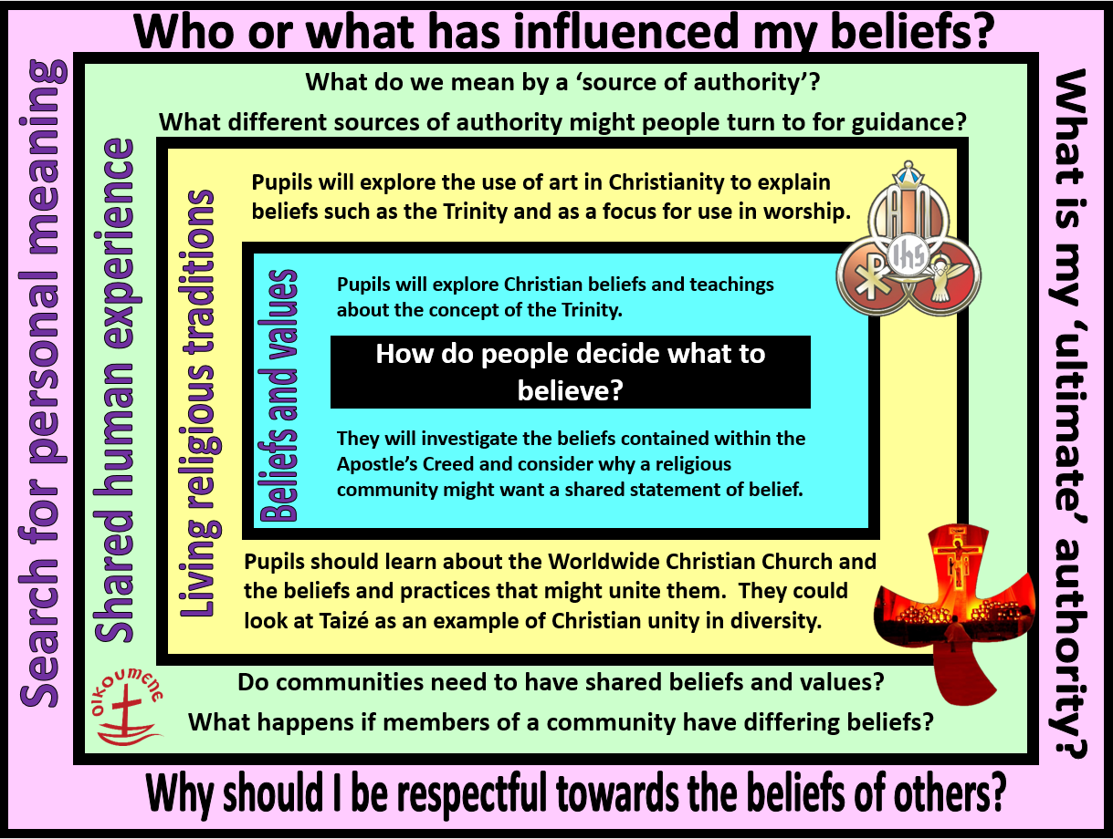
Focus Question: How do people decide what to believe?
This unit enables pupils to explore Christian beliefs and teachings contained in the Apostle’s Creed and how shared beliefs unite the world-wide Church. Pupils should know what is meant by the idea of one God in Trinity and be able to explain the role of each person of the Trinity. They should be able to explain these concepts using subject specific vocabulary and make connections between beliefs, teachings and practices.
Pupils will begin to explore diversity within Christianity by looking at differences in worship. They should consider different ideas about diversity within a community – and the importance of being respectful of difference. Pupils should know that there is one worldwide Christian community - the Church – but that there are many types of Christians and churches that belong to this.
Pupils will have opportunities to explore the question of how people can live together well in modern Britain – and the value of being united in diversity.
Field of Enquiry | Possible Teaching Ideas
Shared Human Experience  1 | - Put pupils into groups and ask them to work together to write a poem to express the shared ideas and values of the school community. (Do not discuss these as a class first, allow pupils to decide on what these are within their groups)  - Ask pupils to read their poems aloud to the class. Discuss similarities and differences between the groups. Are there any key ideas that all groups agree on? Were there any surprising ideas?  - Does it matter if people within a community have different ideas and opinions? What are the advantages and disadvantages of having different beliefs and values in a community?  - Explain that religious communities often have sources of authority which guide them in their beliefs and values – Consider what might be classed as ‘sources of authority’ for non-religious communities and how these might guide individuals within the community.
Beliefs and Values  2 | - Investigate the Apostle’s Creed. Identify the Christian beliefs and values contained within this declaration and discuss how these might have an impact on a believer.  - Look at a selection of images representing Christian beliefs about the Trinity. Ask pupils to explain how symbolism is used to express beliefs about the nature/role of each person of the Trinity, but also how the three are ultimately one. Encourage pupils to make links between the images and their prior learning about the Apostle’s Creed.  - Pupils could design their own piece of art work to show understanding of the Trinity. This could be used as an assessment task, along with a written explanation.
Living Religious Traditions  3 | - Explain that there is one worldwide Christian church with many branches – denominations. All Christians share the same basic belief in God the creator, Jesus Christ and the Holy Spirit. However, there are differences between how the different churches understand some of the teachings and how they should live a Christian life. Some of these differences are evident in worship – some focus more on a particular aspect of the Trinity.  - Compare different forms of Christian worship – eg. Anglican/Catholic/Salvation Army/Quaker/Pentecostal. Discuss similarities and differences and suggest reasons.  https://www.youtube.com/watch?v=E5-aKSrLXM4&list=PLcvEcrsF_9zJxDHG9JtcCmiAgwVFRW3uK&index=26  - Explain the meaning of ecumenical – the movement to bring together the different denominations to focus on their shared values and bring unity to the Church. Look at Taizé or Iona as examples of a Christian communities united in diversity.
Search for Personal Meaning  4 | - Discuss the difference between fact and belief. Give pupils a list of questions containing some questions which can be answered factually and others that ask about personal beliefs and values. Pupils could do a ‘speed dating’ activity to compare and discuss responses, including what has influenced their answers.  - Pupils could write their own ‘creed’ containing their personal beliefs and values.  - Lead a discussion about the importance of people with very different beliefs and values being able to live together in peace and harmony. Consider the importance of being respectful towards people with beliefs and values that may be different to their own.

Y5 Learning - children will:
- describe what Christians mean when they talk about one God in Trinity  - identify the beliefs contained within the Apostle’s Creed  - explain why the Christian community (The Church) might want/need an agreed statement of belief | - describe and explain the meaning of a range of symbols that might be used for the Trinity  - explain how symbols might unite the worldwide Christian Church  - describe the role of places like Taizé where Christians from different backgrounds might come together to worship | - consider what we mean by sources of authority. Give examples of sources of authority that might guide individuals and communities – and the value of these as guidance for life  - discuss different responses to sources of authority | - raise meaningful questions about things that puzzle them  - differentiate between questions that can be answered factually and those that have a range of answers, including personal beliefs and values
Beliefs and values | Living religious traditions | Shared human experience | Search for personal meaning

