Year 5 - Islam
Year 5 Key Question (to be used all year): Where can we find guidance about how to live our lives?
Focus Question (for this investigation): Why is the Qur’an important to Muslims?

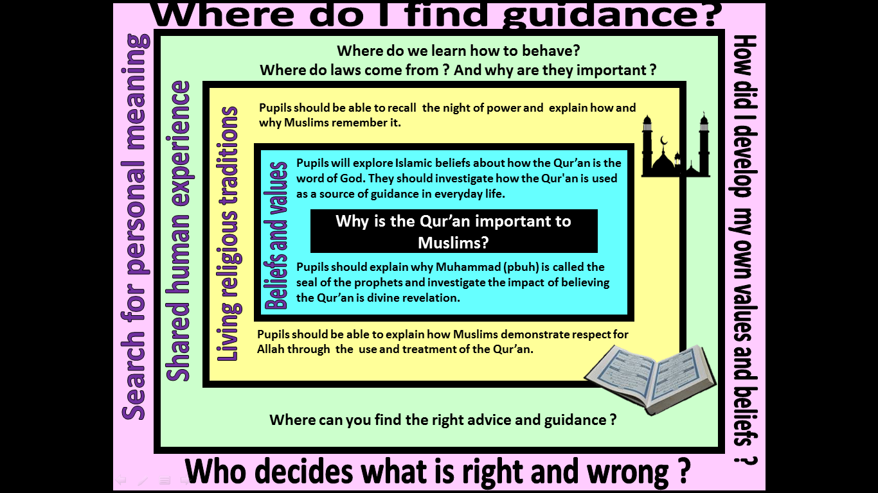
Focus Question: Why is the Qur’an important to Muslims?
This unit enables pupils to explore and examine the origins and role of the Qur’an as a source of wisdom and authority for Muslims. They should gain an understanding of the importance of revelation within Islam and how this impacts on the way that the Qur’an is viewed and treated.
Pupils should make links with prior learning about the night of power (Laylat Ul-Qadr), not only knowing what happened, but also why it is important for Muslims and how it is remembered. They should develop knowledge and understanding of the Prophet Muhammad and how/why he is a role model and source of guidance for Muslims. This is an opportunity to pull together prior learning about the life of the Prophet.
Pupils should have opportunities to discuss what is meant as ‘Ultimate Authority’ and should recognise how this may differ for different members of society – including religious and non-religious individuals and communities. They should be able to link this with their learning about the Qur’an as the word of God and ultimate source of authority for Muslims.
Field of Enquiry | Possible Teaching Ideas
Shared Human Experience  1 | - Discuss why it is important to for communities to have rules - What are the benefits of having a set of clear rules that all members of the community are expected to follow?  - How are rules decided? Who are the rule-makers for our communities? How/why are they chosen for this role? What gives them the authority to tell other people how to live their lives? When/Why might we look to guidance from these people?  - Look at a range of images of the House of Commons/House of Lords – explain to pupils how these groups of people discuss and devise rules and guidance for the nation. Ask pupils to identify symbols of authority within the images (eg. the room itself, seating, clothing).  - Explain that religious people are often guided by their holy books – for members of faith communities these are an important source of authority and guide them in how to live their lives. Ask pupils to name the holy books that they are already aware of.
Beliefs and Values  2 | - Ensure pupils know the basic information about who the Prophet Muhammad was and how he received the Qur’an  https://www.bbc.co.uk/bitesize/clips/zympvcw  https://www.bbc.co.uk/bitesize/clips/zv6sb9q  - Make links with the Five Pillars – The Shahada states that “there is no god but Allah and Muhammad (pbuh) is his final messenger” – What does this tell us about the importance of the Prophet Muhammad? What does it mean to be a ‘final messenger’?  - Explain that for Muslims the Qur’an is the direct word of God as revealed to the Prophet Muhammad. Because of this it is treated with great respect. Discuss what is meant by the word revelation – compare examples of different forms of revelation from across the Abrahamic faiths (Judaism, Christianity and Islam) – Is there anything distinct about how Muslims view the Qur’an?
Living Religious Traditions  3 | - Show pupils a Qur’an stand and discuss its purpose. What is it for? Who might use it? When? Where? Discuss why books are put on stands – think about to keep them clean, and to treat them with respect.  - Show an image of a Muslim using a stand and question pupils about what is happening and why.  - Information page: https://www.worldreligionnews.com/religion-news/muslims-celebrate-the-night-of-power-laylat-al-qadr  - Recap prior learning about Ramadhan. Develop this by explain Ramadan is a time for giving, reflecting and being charitable - every day of this month is special, but the 27th day is the most important as it when the night of power is remembered and this is celebrated as the festival of Laylat al Qadr. On this night, Muslims believe the angels are on earth and their prayers will be heard as the gates of heaven are open.  - Explore Islamic beliefs about angels
Search for Personal Meaning  4 | - Pupils could prepare a presentation about their own source of authority and guidance. They should be able to answer questions posed by the rest of the class.  - Discuss why people may have differing sources of authority in different situations.
Y5 Learning - children will:
- explore Islamic beliefs about the Qur’an as the word of God  - explain how and why the Qur’an is a source of guidance for life for a Muslim  - explain the impact of believing that the Qur’an is divine revelation  - describe and explain what Muslims believe when they describe Muhammad (pbuh) as the seal of the prophets | - explain how and why Muslims might commemorate the Night of Power  - describe and explain a variety of ways that Muslims might show respect for the Qur’an – and how this symbolises their respect for God  - explain how the teachings of the Qur’an might influence the actions and choices of a Muslim | - discuss where people might look to for guidance about how to live – consider a range of sources of wisdom and authority  - suggest when and why people might want guidance about how to live | - discuss who or what has guided them in their own beliefs, values and commitments  - reflect on what ‘ultimate authority’ might mean for them
Beliefs and values | Living religious traditions | Shared human experience | Search for personal meaning

