Year 4 Christianity (Church)
Year 4 Key Question (to be used all year): How should we live our lives?
Focus Question (for this investigation): What does ‘love your neighbour’ really mean?

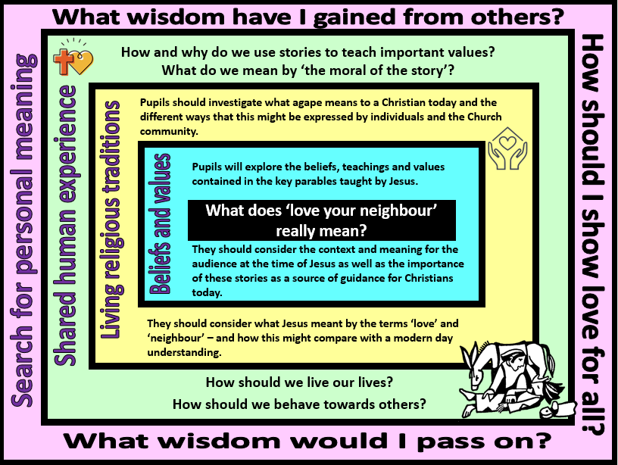
Focus Question: What does ‘love your neighbour’ really mean?
This unit investigates the Christian teaching of agape- a selfless love of others. Pupils will explore how important messages and guidance can be passed on through stories and will focus on Christian teachings contained in the parables that Jesus told to his followers. They will then discover examples of how modern Christians show a love for their neighbour and reflect on what they message they would want to pass on to future generations.
Field of Enquiry | Possible Teaching Ideas
Shared Human Experience  1 | - Listen to some of Aesop’s fables at https://www.bbc.co.uk/programmes/p05415y7 or read printed versions. Explain what the word ‘moral’ means. What are the morals of the fables?  - Fables have existed for centuries and were initially passed down orally before they were written. Ask pupils why they think these stories are remembered and passed on whilst others are forgotten. Why do they think that parents and teachers often choose fables to share with children?
Beliefs and Values  2 | - Jesus taught his followers using parables. These were stories with a moral that made use of settings and situations that were familiar to the world in which his followers lived so that they were easier for them to understand. He told these parables to encourage those who heard them to act or think in a particular way in response to them.  - Read the Parable of the Good Samaritan (Luke 10:25-37) or watch a version at https://www.bbc.com/bitesize/clips/zcyr87h . Hot seat characters from the story or hold an imaginary talk show. Discuss the characters’ actions and the motivation for their behaviour and choices. What message do the pupils think Jesus was trying to pass on to his followers? How can this parable guide modern Christians?  - Focus on the Parable of the Unforgiving Servant (Matthew 18:21-35) https://www.youtube.com/watch?v=yeQ-Hdpewiw . Before you read it give each pupil one of the characters to focus on: the king; the first servant or the second servant who owed a few dollars. As they hear/watch the story the pupils should make note of how their character thinks, feels and acts. The pupils could then retell the parable in role as their character.  - Whose behaviour in the parable was right and whose was wrong? What does this story teach Christians about what God is like? How do they know?  - Again, focus on how modern Christians can learn from this story even though it was first told two thousand years ago. Pupils could create role plays in which a similar scenario is told in a modern context.
Living Religious Traditions  3 | - In St Matthew’s Gospel, when asked what was the greatest commandment, Jesus said, "'Love the Lord your God with all your heart and with all your soul and with all your mind.' This is the first & greatest commandment. And the second is like it: 'Love your neighbour as yourself.' This Christian love is known as agape- a selfless love of others.  - Find out about the life of Mother Teresa (https://www.twinkl.co.uk/resource/t2-re-379-ks2-mother-teresa-powerpoint or http://www.historyforkids.net/mother-teresa.html contain helpful information). Pupils could create a comic strip to retell key events from her life.  - In 1979 Mother Teresa received the Nobel Peace Prize. Pupils could imagine that they are presenting the award to her and write a speech detailing why she deserves the award for showing agape.  - The ‘neighbour’ that Christians support is not always someone known or nearby. There are many Christian charities that work to support people both in this country and around the world who need help. Research some of these: such as Christian Aid www.christianaid.org.uk ; CAFOD www.cafod.org.uk or the St Vincent de Paul Society www.svp.org.uk . Christians can show their love of others by raising money and donating it to one of these charities. Pupils could create a leaflet or poster for one of the charities explaining how it shows agape in its work.  - Create a mind map of ways in which a Christian could show their love of others in their daily lives.
Search for Personal Meaning  4 | - Identify stories that the pupils have read, watched or been told that have taught them something. Who would they recommend these stories to? Why?  - Fables and parables contain messages that have been passed on from generation to generation to guide people to live good lives. Ask pupils to identify one or two key messages that they would like to be passed on. Identify ways in which they could do this and allow the children to explore their ideas.

Y4 Learning - pupils will:
- retell some of the main parables of Jesus  - explain how and why these might be an important source of guidance for Christians  - suggest ways that Christians might put these teachings into action in the 21st century | - describe and explain (with examples) Christian attitudes about how to treat others  - explain the importance of love for all (agape) as part of Christian life, and the ways that this might be expressed | - explain (with examples) how and why people might use stories to pass on wisdom and guidance  - discuss how and why fables might be an important aspect of human history and culture | - discuss examples of wisdom and guidance that they have learnt from stories  - consider what messages/words of wisdom they would want to pass on to future generations – and how they would do this
Beliefs and values | Living religious traditions | Shared human experience | Search for personal meaning

