Year 3 Hindu dharma
Year 3 Key Question (to be used all year): Who should we follow?
Focus Question (for this investigation): Why is family an important part of Hindu life?

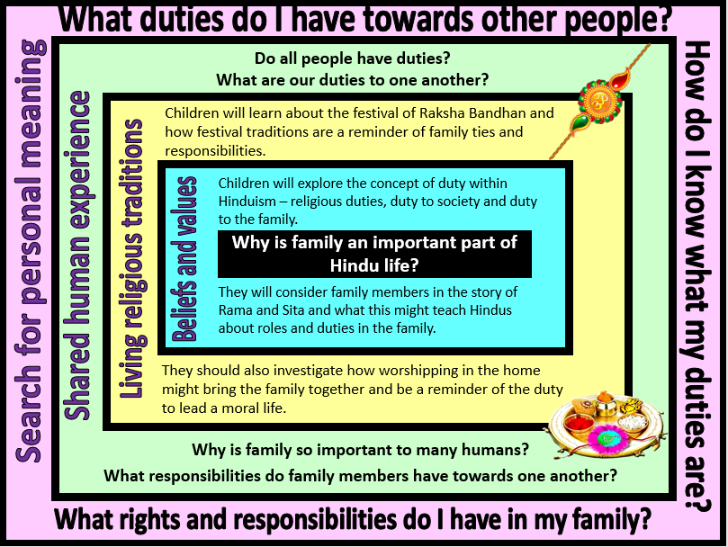
Focus Question: Why is family an important part of Hindu life?

Field of Enquiry | Possible Teaching Ideas
Shared Human Experience  1 | - Look at images of different families – could include both human and animal. Talk about what makes a family a family and the different roles and responsibilities that family members might have towards one another. Link these roles with the idea of duty – it is the sense that there are certain things that we should do.  - Discuss why family is an important part of human life. What role does the family play in developing an individual person? What role does family play in building the wider community? What behaviours and values might people learn from growing up within a family unit?  - Link with the idea of duty by asking children what duties they have within their family (chores, tidying up, being kind to a sibling, being polite, following rules etc.). How do these duties contribute to family life?
Beliefs and Values  2 | - Introduce the Hindu concept of dharma. It is often translated as ‘duty’ but can also be understood as the right way of being – behaving in a certain way because it is the right way to live.  - Read a children’s version of the story of Rama and Sita. Children could create their own puppets and perform the story or act it out.  - Discuss the different family roles in the story and how duties of family members are illustrated in this Hindu text. (King Dasharatha keeps his promise to his wife, Rama obeys his father, Sita goes into exile with her husband, Lakshman is the loyal brother – Hanuman is not a family member, but represents the idea of devotion to God).  - Discuss what a Hindu might learn about dharma from reading this story. As humans, our duties change during the course of our lives. The Ramayana (the story of Rama and Sita) is popular with all ages – why might different Hindus take different messages from the story?
Living Religious Traditions  3 | - Pupils should learn about the Hindu festival of Raksha Bandhan. Teachers can find information here https://www.reonline.org.uk/festival_event/raksha-bandhan/  - Children could be given a photograph of the festival celebrations and asked to explain what is happening (including the deeper meaning) – this could be used as an assessment task.  - Look at a photo/image of a Hindu home shrine and discuss why the family might want to worship together in the home.
Search for Personal Meaning  4 | - Create a list of the duties that they have – in 3 columns: duty to self, duty to family, duty to the wider community. Relook at the word duty – have their ideas about duty changed at all? Where do pupils get their sense of ‘duty’ from?  - Design and write a thankyou note to family member as a way of expressing gratitude for the relationship.

Y3 Learning - children will:
- develop an understanding of the importance of duty and commitment to many religions  - know that following dharma (religious duty) is an important part of Hindu life  - suggest the impact of belief in dharma, particularly the belief that there are three ‘debts’ – duty owed to God/the deities, duty owed to teachers, and duty owed to family | - describe how and why Hindus might celebrate Raksha Bandhan  - identify aspects of the celebration which remind Hindus of their dharma  - identify religious teachings contained within a Hindu story – and suggest how these stories might be used to teach Hindu children about dharma (eg. What teachings about duty to family are expressed in the story of Rama and Sita?) | - identify sources of authority and inspiration  - consider what our ‘duties’ as human beings are | - reflect on their own duties – to themselves, to their families, to their communities  - discuss who or what they follow – and why
Beliefs and values | Living religious traditions | Shared human experience | Search for personal meaning

