Year 3 Christianity - Jesus
Year 3 Key Question (to be used all year): Who should we follow?
Focus Question (for this investigation): What does it mean to be a disciple of Jesus?

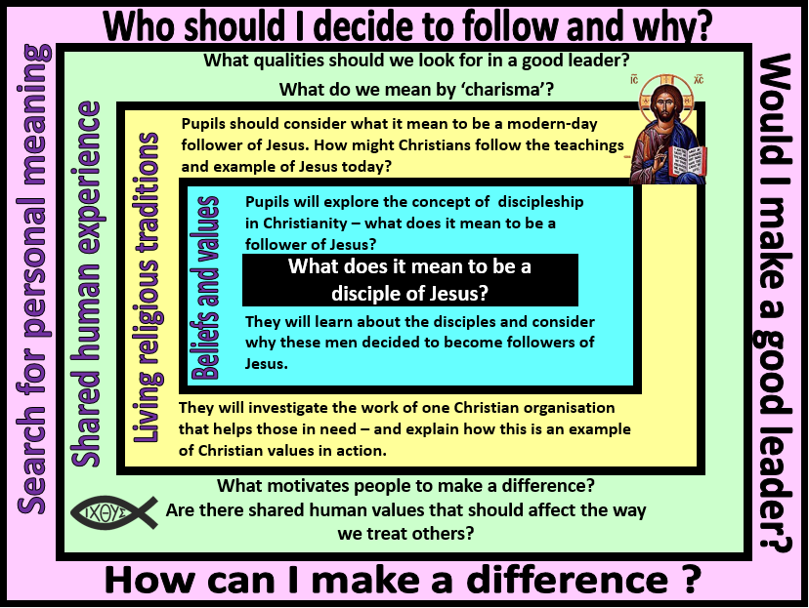

Focus Question: What does it mean to be a disciple of Jesus?
This unit enables pupils to explore what it means to be a follower of Jesus – both at the time of Jesus and today. References should be made to previous learning about Jesus – ie. That Jesus is special to Christians and is described as a ‘light to the world’, someone who brought hope to the world. This may be a good opportunity to introduce the work Messiah when talking about why some people at the time decided to devote their lives to following Jesus. This should then lead into an exploration of how Christians today might try to follow the example and teachings of Jesus – What does it mean to be a true follower?
Within this unit, pupils will reflect on the qualities that good leaders have and the idea that some people have a ‘charisma’ that attracts followers.
Field of Enquiry | Possible Teaching Ideas
Shared Human Experience  1 | - Talk about what it means to have the ‘X factor’ – what does it mean to have charisma?  - Diamond nine activity – what are the most important qualities of a good leader? (friendly, good speaker, kind, good listener, honest, brave, confident, organised, intelligent)
Beliefs and Values  2 | - Read/watch the story of Jesus choosing his first disciples (Luke 5:1-11; Matthew 9:9-13). Discuss why these two men thought that Jesus was ‘the one’. What leadership qualities might Jesus have demonstrated to them? (refer back to ideas from the diamond 9)  https://www.youtube.com/watch?v=iypUNd5yTn0  https://www.youtube.com/watch?v=OZyMPI9kTfw  - Focus on the character of Simon Peter. Talk about the fact that he was a fisherman and probably worked long unsociable hours. He would have been a simple, uneducated but hardworking man – why might Jesus value these qualities in a follower?  - Discuss what qualities about Jesus might have made Simon Peter and Matthew want to follow him and leave everything behind.  - Hot-seat activity: ask a child to imagine that they are Simon Peter and they need to tell their family and friends that they are leaving home to become a disciple of Jesus (a man he has just met). The other children in the class could take on the role of family and friends and ask questions – or this could be done by the teacher.
Living Religious Traditions  3 | - Pupils should look at the teaching of Jesus to ‘leave your nets and follow me… I will make you fishers of men’ and consider what Jesus might have meant by this.  - Talk about the idea that Jesus was a friend to those in need and how/why Christians might try to follow this example in the world today. Match a selection of images of Christians helping those in need to statements  - Write a ‘job advert’ for a modern day disciple of Jesus
Search for Personal Meaning  4 | - P4C activity – using a picture of people helping others as a prompt. Ask pupils to raise questions about why people might want to volunteer to help those in need. Vote for the best questions to discuss as a class.  - Look back at the list of qualities that they think are needed by good leaders. Which of these qualities do they think they have? Which could they develop and how?

Y3 Learning - children will:
* know what is meant by discipleship  * know about the people who became disciples of Jesus – and suggest why these people decided to follow Jesus  * identify beliefs and values within religious teachings (eg. ‘Follow me and I will make you fishers of men’ – Matt 4:19) | * describe how and why Christians might try to follow the example of Jesus through mission and charity work  * describe the work of one Christian organisation that aims to help people, and how this work is an expression of their Christian beliefs | * talk about what it means to have charisma  * describe what makes a good leader and why people might want to follow him/her  * discuss what motivates people to want to make a difference | * reflect on their own leadership abilities  * discuss their own desires to make a difference in the world/in their communities
Beliefs and values | Living religious traditions | Shared human experience | Search for personal meaning

