Year 2 Hindu Dharma
Year 2 Key Question (to be used all year): How should we respond to the things that really matter?
Focus Question (for this investigation): How might people express their devotion?

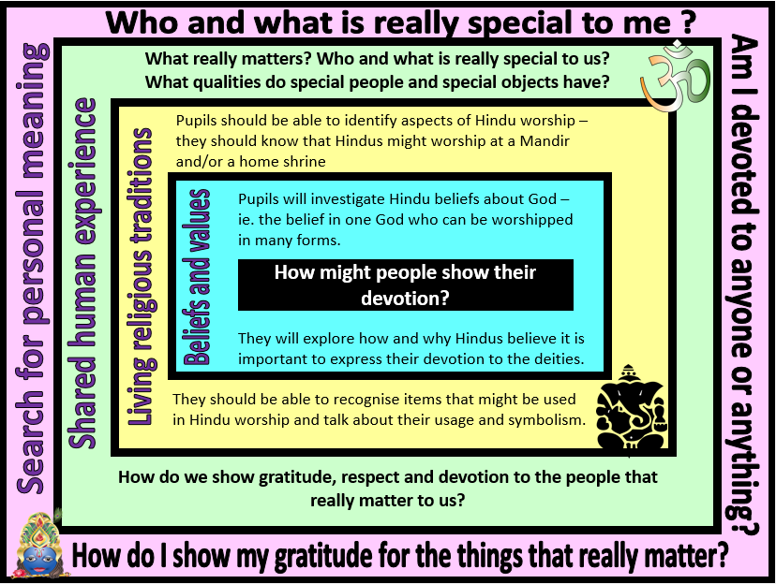
Focus Question: How might people express their devotion?
This unit enables pupils to explore the purpose of and some of the practices associated with Hindu worship. The focus includes beliefs about Brahman, family, community and Worship.
Opportunities are provided for pupils to investigate ways that Hindus might express their devotion to God through worshipping the deities. They should know that Hindus believe in one God with many forms and so whichever deity is worshipped, it is ultimately a way of worshipping God.
They should have opportunities to discuss the concept of being devoted to something/someone – and the various ways in which human beings might show their devotion through clothing, special words or songs, rituals and actions.
Field of Enquiry | Possible Teaching Ideas
Shared Human Experience  1 | - Identify a special event or person, e.g. Mother’s Day, Celebration Assembly. Discuss how the occasion or person is made to feel special. Brainstorm ways that children show parents or close friends that they are special and valued, e.g. hugs, giving compliments, asking for help.  - Talk about what it means to be devoted to something/someone  - Look at images of football supporters – what symbols do they use to show their devotion?
Beliefs and Values  2 | - Look at a selection of 3D geometrical shapes. Ask the children to count how many sides each shape has. Explain that even though each side is different, it is a single shape – eg. a cube has six sides, but is a single cube.  - Explain that in Hinduism, there is believed to be one God (Brahman) who can be seen in many ways. This is often explained as one God in many forms.  - Look at some pictures of various Hindu deities (eg. Shiva, Vishnu, Brahma, Lakshmi, Durga, Saraswati). Explain the role of each deity and ask children to suggest why they are portrayed the way they are – eg. How might the objects that they are holding help them in their role?
Living Religious Traditions  3 | - Introduce the vocabulary ‘arti’ (the ritual) and ‘puja’ (the act of worship).  - Explore the items on a puja tray and ask the children to think about what it may be for (bell, incense holder and incense stick, diva lamp, water pot and spoon and kum kum powder to put on the worshipper’s head)  - http://www.crickweb.co.uk/ks2re.html  - http://credo.ysgolccc.org.uk/arteffactau/puja.htm .  - Create a list of questions about the object on a puja tray.  - Match object cards with definitions on.  - Compare images shrines in the home and mandir. Talk about the similarities and differences.  - Invite a Hindu to demonstrate an Arti ceremony or arrange a visit to a Mandir http://www.ghspreston.co.uk/contact-us/temple-visit/
Search for Personal Meaning  4 | - Ask the children to think about what is special to them. Create an area in the classroom to put special objects from home or paint pictures of them. Encourage children to give reasons for their choices.  - Play some Indian music to set the correct atmosphere and look at some of the objects in the special space. Maintain a calm environment where everyone is quiet and respectful of each other.

Y2 Learning - children will:
* know that Hindus believe in one God (Brahman) who can be worshipped in many forms  * know that these forms (the deities) have different qualities and are portrayed in different ways  * suggest why Hindus might believe that it is important to show devotion to the deities | * know that Hindus might worship at a Mandir and/or the home shrine  * suggest why worship in the home might be important  * describe the meaning and symbolism of items used in worship (eg. arti lamp, items on the puja tray) | * talk about qualities that make some people special  * identify ways in which humans show their gratitude to the people who matter in their lives | * talk about who is special to them and why  * reflect on who they should be grateful to and how they might show this in words and actions
Beliefs and values | Living religious traditions | Shared human experience | Search for personal meaning

