Year 2 Christianity - Jesus
Year 2 Key Question (to be used all year): How do we respond to the things that really matter?
Focus Question (for this investigation): Why do Christians say that Jesus is the ‘Light of the World’?
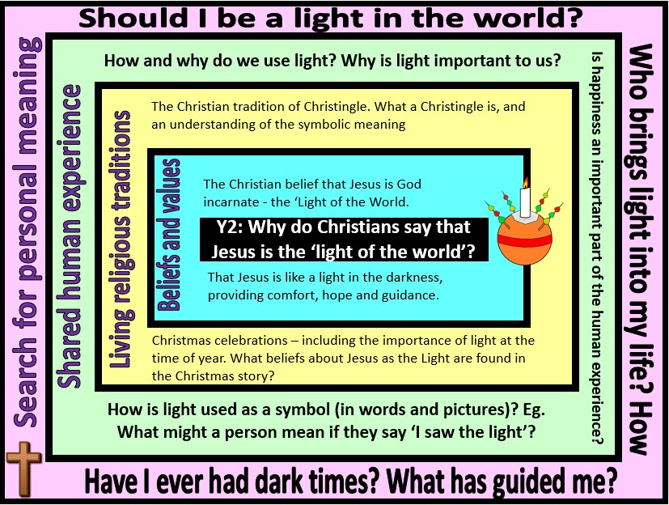

Focus Question: Why do Christians say that Jesus is the ‘Light of the world’?
This unit enables pupils to explore the use of light to and how it might be used in religious communities to indicate the presence of God and as a description for Jesus as God incarnate. Pupils should be able to make links between the imagery and symbolism of light in the Christian context and significant events in their own lives.
This unit should build on the Y1 unit ‘Why is Jesus special to Christians?’ – Pupils should be encouraged to recall information about why the birth of Jesus is important to Christians and why Jesus is seen as a gift to the world.
Field of Enquiry | Possible Teaching Ideas
Shared Human Experience  1 | - Look at images of light sources.  - Categorise uses of light, eg it removes dark, it guides, gives heat etc.  - Collect examples of language using light images, eg, bright spark, dark mood, dawned on me, saw the light, light at the end of the tunnel.  - Make the room dark, light candles (electric would be safer). How did they feel in the dark, then in the light?

Beliefs and Values 2 | - Jesus is known as the ‘light of the world’. Discuss the meaning of this.  - Look at Bible references to Jesus and light (John 1: 4 – 5 and 9, Luke 2:32 and John 8:12). What might Christians mean when they talk about Jesus as a light to the world?  - Look at some pictures showing Jesus and light (eg. ‘The Light of the World’ by William Holman Hunt).
Living Religious Traditions  3 | - Explore how light is used in Advent – use of advent candles, advent services.  - Learn about the Christingle. http://www.topmarks.co.uk/christmas/Christingle.aspx , http://www.childrenssociety.org.uk/what-you-can-do/fundraising-and- events/christingle/what-christingle.  - Interview or email a Christian and ask how Jesus is a light to them and how that knowledge alters their actions to others.
Search for Personal Meaning  4 | - Could the children be ‘a light’ to others? Brainstorm good qualities that the class consider are worth following. Record the ideas as posters, poems, writing.  - Focus on a lighted candle. Can they think of a time when they brought light to a situation? How?  - Talk about a time when it has been dark or sad – and how a person has helped bring ‘light’ to the situation.  - Relate all this to Jesus and his role as ‘a light to the world’. Children consider how they could turn dark to light in their own lives.

Y2 Learning - children will:
* suggest what Christians | * identify ways in which | * identify different ways that | * ask questions about the
might mean when they refer | Christians might use light as | humans use light | value of sources of light in
to Jesus as ‘the Light of the | part of their Christmas | * discuss the importance of | their own lives
world’ | celebrations (advent candles, | light – as a source of | * talk about the people who
* talk about the different | candle-light carl services, | comfort, security and hope | provide comfort, security
titles that might be given to | Christingle) – and the | * talk about how and why | and hope for them
Jesus – Christ/ Messiah/ | symbolic meaning | light might be an important | * suggest ways in which they
Saviour/Son of God | * talk about the different | symbol | might be a light for others
 | ways that Christians might
 | celebrate Christmas
Beliefs and values | Living religious traditions | Shared human experience | Search for personal meaning

