Year 2 Judaism
Year 2 Key Question (to be used all year): How should we respond to the things that really matter?
Focus Question (for this investigation): What aspects of life really matter?

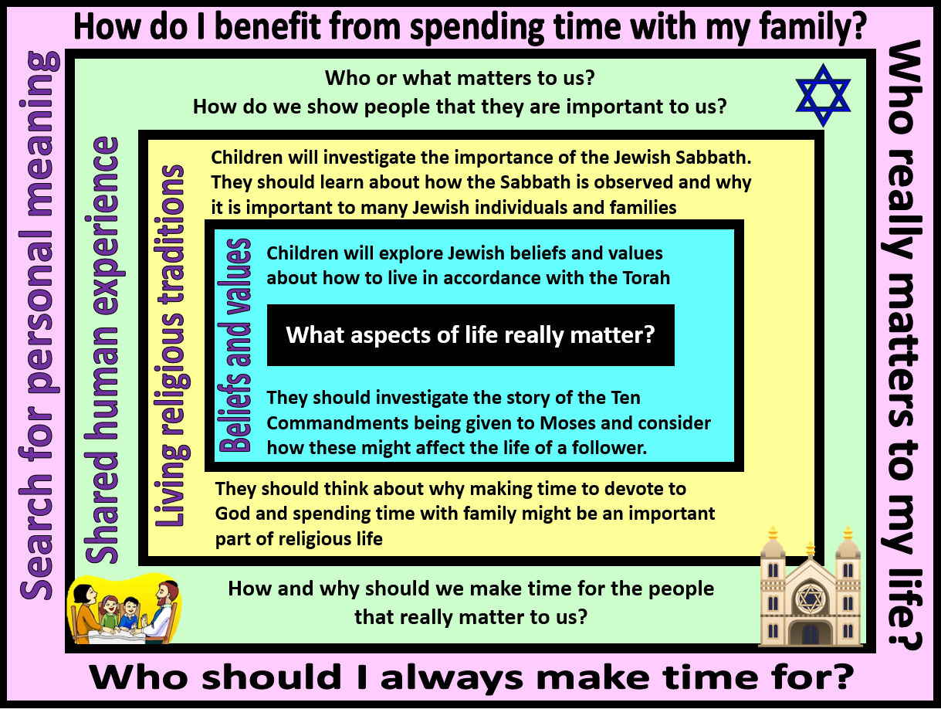
Focus Question: What aspects of life really matter?
In this unit pupils will examine Jewish beliefs and practices linked to the Sabbath (Shabbat). Opportunities are provided for pupils to explore the significance of the Sabbath and why Jewish people keep the day holy.
Within this, they will discuss the importance of holy days and how these might unite families and give time to spend together.
Children should have opportunities to reflect on the value of making time for those things that are important to us – for religious people this may be God, but for others it may be the family and friends. Making time is a way of showing that we are thankful to have these people in our lives.
In Year 1 children will have learnt about Noah, and why he is important to Jewish People. In this unit children will build on that understanding by learning about other important Jewish figures.
Field of Enquiry | Possible Teaching Ideas
Shared Human Experience  1 | - Think about who in our lives matters the most to us. Ask the pupils who are the most important people in our lives and why?  - Talk about important people within our wider world. Who is important to lots of people, why are they important?  - How do we show these people that they are important to us? Why do you show them that they are important to us?
Beliefs and Values  2 | - Explain the story of Moses and how God appeared to him through the burning bush. Discuss the symbolism of a burning bush and why God chose to appear in this form. What do the flames represent? Warmth, power etc. Ask the children to create flames with words written up them for a display.  - Watch the beginning of https://www.youtube.com/watch?v=yHKFvxgQOFI Discuss Moses’ trust in God and how he followed his instructions. Compare this to the Pharaoh’s response to Moses’ instructions. What happened as a consequence of the Pharaoh ignoring Moses? Ask two children to hot seat as Moses and Pharaoh. The rest of the class can ask the children questions about what their actions, and the reasons behind them.  - Finish watching the above clip, showing how Moses received the 10 commandments. Create a list of the 10 commandments as a class and discuss the order in which they are written. Talk about if the order is important and why. Discuss why ‘Keeping the Sabbath Holy’ is higher up than other serious crimes – hurting other people, theft etc.  - How does believing in the 10 commandments influence the life of a Jewish person? Talk about why it is important to Jewish people to keep the Sabbath holy, and as a day of rest. Discuss a Jewish person’s belief in the Torah as a holy book, and that the stories within it are rules about how our lives should be lived.
Living Religious Traditions  3 | - Watch https://www.bbc.co.uk/bitesize/clips/z3hyr82 and discuss how the Sabbath is kept holy in a Jewish Household. How many parts of the ceremony can the children recall? What the reason for each of the parts?  - Discuss the blessing given by the family. What is special for Jewish children about being blessed by members of their family? Look at the words of the blessings, what makes them special? Talk about the Sabbath meal being a time for families to come together and enjoy each other’s company as a gift from God.  - Explain about the foods that are typically eaten during the Sabbath and that they are special as they represent gifts from God as Moses was the gift from God for the Israelites. Create a Sabbath plate with items traditionally eaten.  - Discuss the woven Challah Bread and that the plaits represent the interweaving of lives and well as a woven item being stronger than the original strands. Children can make their own ‘Challah Bread’ using play dough or salt dough, which can then be baked.
Search for Personal Meaning  4 | - When do you see the people who matter the most in your life? Is there a time when you see more of these people? Birthdays, celebrations, festivals or holy days? Why are these people so important to you? Children can could make a list of the people who are special to them and create an invitation to come to a special meal.  - Are there people that we don’t see enough of? Friends and family who live further away perhaps. Children to decide who they would like to make more time for in their lives and how they could do this.  - What food would you have at a special dinner for important people in your life? Why are the food items special to you? Pupils can create a dinner plate and label it with what the items are, and why they are special to them.

Y2 Learning - children will:
- retell the story of Moses being given the Ten Commandments  - know some of the Commandments – eg. Keep the Sabbath Day holy, Respect your mother and father  - suggest ways in which the Ten Commandments might influence the life of a believer | - talk about how keeping the Sabbath day holy might influence a Jewish person  - talk about how the Sabbath is a way of making time for God and family  - know about the Jewish tradition of Friday night dinner | - talk about why some people are particularly special to us  - suggest how and why it is important to make time for the people who really matter in our lives | - talk about the people who are special to them and identify the importance of these relationships in their lives  - give examples of why it is important to spend quality time with the people who matter
Beliefs and values | Living religious traditions | Shared human experience | Search for personal meaning

