Year 2 Christianity - Church
Year 2 Key Question (to be used all year): How do we respond to the things that really matter?
Focus Question (for this investigation): What unites the Christian community?

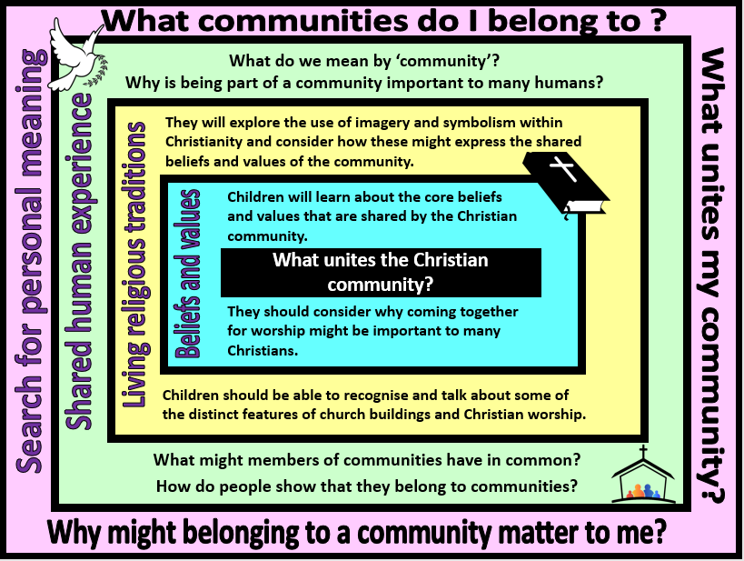

Focus Question: What unites the Christian community?
In this unit, children should explore the core beliefs and symbols of Christianity. They should know that belief in one God and Jesus Christ unite the Christian community and that the cross is an important Christian symbol. This should build on their previous learning about symbolism contained in the idea of Jesus as ‘the light of the world’.
They should learn about the importance of the church as a place to bring together the community for worship and Christian fellowship. Children should be able to talk about key aspects of worship such as prayer, use of music and readings from the Bible.
Children should also have opportunities to consider why people might want to be part of a community and the shared values and interests that bring people together. They should be able to talk about communities that they belong to and what unites them with others.
Field of Enquiry | Possible Teaching Ideas
Shared Human Experience  1 | - Look at a range of signs, symbols, logos – talk about how these reflect a message or a set of values. Discuss why people might sometimes want to use symbols rather than words.  - Investigate your school logo or another emblem relevant to your local community. What is the meaning of this image? Does it reflect the values of the community?
Beliefs and Values  2 | - Look at a selection of Christian symbols. Match symbol to a description of the belief shown.  - Talk about the beliefs that are central to Christianity – all children should be able to give a simple summary of these.  - Look at the design of a traditional Catholic/Anglican church. Discuss how the central beliefs are evident in the church building. Talk about why Christians might think it is important to gather together to pray and worship God.
Living Religious Traditions  3 | - Continue to investigate the interior of the church building and how different parts of the church are used during worship (eg. Pulpit, lectern. altar)  - Investigate Christian worship – including the importance of prayer, reading from the Bible, use of worship and sharing the bread and wine. Explain that there are different forms of Christian worship, but that there are also common practices amongst all Christians.  https://www.youtube.com/watch?v=E5-aKSrLXM4  - Look at images of church notice boards – what else is the church used for other than worship? Discuss how and why a church might serve the local community.  - Children could work in teams to design/build a model church and present it to the class. (Photographs could be taken of the work and stuck in books – children could then write about their church design and how it might be used by a Christian community. This could be used as an assessment task – children should be able to use some religious vocabulary, select appropriate images and design features and explain how the building might be used).
Search for Personal Meaning  4 | - List the various communities that pupils belong to and discuss why it is important to feel a sense of belonging. What communities matter most to pupils and why?  - Look at your school website – does the design and any photos used on the site reflect your school community’s values? What unites your school/your class as a community? What events bring your community together and contribute to a sense of unity?

Y2 Learning - children will:
- suggest beliefs and values that might unite the Christian community  - talk about why some Christians might think it is important to come together to worship God | - identify symbols (images and actions) used in Christian worship  - talk about how and why symbols might be used in Christianity  - identify and describe features of a church | - identify signs and symbols in the world around them  - talk about the school logo – what values it might represent and how it might unite the school community | - ask thoughtful questions about signs and symbols  - talk about communities that they belong to – and how they show their commitment to these communities
Beliefs and values | Living religious traditions | Shared human experience | Search for personal meaning

