Year 2 Islam
Year 2 Key Question (to be used all year): How should we respond to the things that really matter?
Focus Question (for this investigation): Why do Muslims believe it is important to obey God?

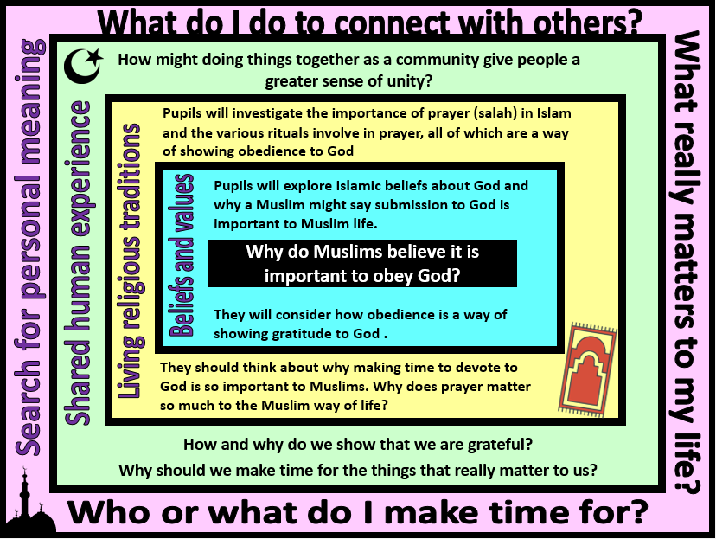
Focus Question: Why do Muslims believe it is important to obey God?
In this unit pupils will examine Islamic beliefs and practices linked to prayer. Opportunities are provided for pupils to explore the significance of prayer as one of the Five Pillars of Islam and to consider the purpose of prayer for religious people.
Within this, they will discuss the importance of rituals and how these might unite communities and give a sense of order, security and belonging to individuals.
Children should have opportunities to reflect on the value of making time for those things that are important to us – for religious people this may be God, but for others it may be the family and friends. Making time is a way of showing that we are thankful to have these people in our lives.
Field of Enquiry | Possible Teaching Ideas
Shared Human Experience  1 | - Think about the routines that people might have - the things we do every day. Ask pupils to give examples of their own special routines – daily and weekly routines. Are there any places that they visit at the same time each week?  - Talk about the routines that exit within the school/classroom and how these are helpful to the school community and individuals  - Ask a pupil or another member of staff to come into the class and not follow basic rules – eg. eating food and throwing rubbish onto floor, talking over teacher, not following instructions. Discuss why it is important to have behaviour expectations as part of the classroom rules. Talk about how following these rules links respect for others and obedience to authority.
Beliefs and Values  2 | - Explain the Shahada (the declaration of faith) https://www.bbc.com/bitesize/clips/zstfgk7 and the Islamic belief that they should live in obedience to God through following the teachings of the Qur’an and the example of the Prophet Muhammed. Explain that rituals such as daily prayer, attending mosque and fasting each year during the month of Ramadan help Muslims to remember to make time for God.  - You could read a children’s version of ‘the Night Journey’ (eg. the one from ‘Goodnight Stories from the Life of the Prophet Muhammad’). Ask children to think about why God wanted the people to pray so often, and why Moses might have thought that people would not be able to pray 50 times a day.
Living Religious Traditions  3 | - Look at images of Muslims in prayer. Ask children to think about why Muslims might pray in this way – how might it be a way of showing their obedience to God?  - Explain that for Muslims, prayer is a way of showing commitment and obedience to God. Wudu (ritual washing before prayer which is compulsory) https://www.bbc.com/teach/class-clips-video/wudu-the-washing-ritual/zvmrwty is both practical (keeping clean) and spiritual (a reminder that when humans come to speak to God, being clean in body is symbol of being pure in heart and mind).  - Investigate where and how Muslims pray https://www.bbc.com/teach/class-clips-video/the-mosque/zmctvk7  - Pupils could visit a Mosque or you could invite a Muslim into your class to demonstrate the prayer positions and talk about the importance of prayer in Islam.  - Possible assessment activity – Give pupils a series of photographs linked to prayer in Islam (eg. a mosque, shoe rack, wudu being performed, prayer hall, prayer mat, Muslims praying etc). Ask children to sequence the images in a logical way to tell the story of a Muslim going to prayer. Pupils should be encouraged to use any specialist vocabulary in their story.
Search for Personal Meaning  4 | - P4C activity – look at pictures of a range of people demonstrating their commitment (an athlete rehearsing, a person collecting for charity, someone rehearsing a play, a rainbow/cub scout meeting, a child visiting grandparents) Ask children to share examples of things that they do on a regular basis as a sign of their commitment and belonging.  - Ask pupils to reflect on what really matters in their life. Share ideas with their partners and see what similarities and differences they have.  - Discuss why it is important to make time for the people, communities and values that really matter to us. Ask them to suggest why we sometimes forget to do this and the impact that this might have on our relationships.

Y2 Learning - children will:
- suggest why Muslims believe that it is important to respect God  - talk about why Muslims would want to show their gratitude to God  - know that submission to God is an important aspect of Islamic life | - identify that Islamic beliefs about God motivate most Muslims to pray on a regular basis  - describe the rituals of Islamic prayer (salah), including wudhu and use of a prayer mat  - suggest how making time for the five daily prayers is an act of submission | - talk about the ways in which shared rituals might unite communities (make links with the way that the Islamic community – the Ummah – is united by prayer)  - identify ways in which humans show their gratitude | - talk about the things they do on a regular basis as a sign of their commitment and belonging  - reflect on who they should be grateful to and how they show this
Beliefs and values | Living religious traditions | Shared human experience | Search for personal meaning

