Year 1 Christianity - Church
Year1 Key Question (to be used all year): What do people say about God?
Focus Question (for this investigation): How might some people show that they ‘belong’ to God?
?

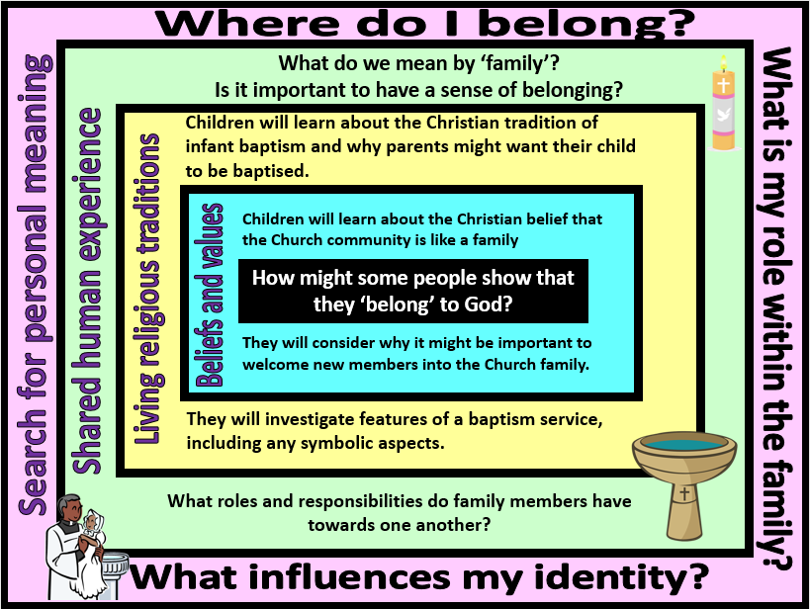
Focus Question: How might some people show that they ‘belong’ to God?
In this unit children will explore how the rite of baptism shows that Christians belong to Gods’ family - the Church. They will identify symbols, items and people liked to baptism and will reflect on why, in some Christian communities, parents choose to have their baby baptised. This will build on their prior learning about Christian belief in God the Father and how religious beliefs might be expressed through symbolic images and actions.
The focus of the enquiry is on belonging, sharing and learning within the practice of baptism and in pupils’ lives.
Field of Enquiry | Possible Teaching Ideas
Shared Human Experience  1 | - Ask children and staff to bring in photographs of their families to share with the class. Talk about who is in their family. Identify the different relationships that they children may have within their families e.g. brother/sister, son/daughter, cousin.  - What makes a good family? How does a family look after children?  - What other groups do they belong to? (e.g. school, class, clubs, religions). Are these groups like families? How do they show that they belong?
Beliefs and Values  2 | - Talk about why Christian parents may decide that they want to have their baby baptised. Christians believe that the Church community is like a family. Remind children that they have previously found out that Christians think of God as being like a father.  - In some Christian communities, parents ask for their child to be baptised so that it can belong to this family and can develop a relationship with God. They believe that this will mean the baby will grow up with the support of the Church family as well as their own family.  - In the infant baptism ceremony the parents will also say thank you to God for the gift of their child.  - Discuss why the children think that it is important for Christians to make new members of the Church family welcome.
Living Religious Traditions  3 | - Watch a video of an infant baptism https://www.bbc.com/bitesize/clips/zr34wmn Identify who is involved in the baptism and what is used. Talk about the cross that is made on a baby’s head in the context of welcoming a child into the family of God in the church. Ask them what the cross symbolises.  - Invite children who have personal experience of going to baptisms to talk about them and share any photographs or artefacts that they have.  - Visit a church and identify the font. Talk to the priest/minister about what they do at a baptism and why it is an important ceremony of belonging. Alternatively take a virtual tour of a church and locate the font at http://e4education.uk-virtualtours.co.uk/church/  - Hold a baptism for a class doll/teddy. Create invitations for other members of the school community to attend. Work with the children to identify who and what they will need for the baptism.  - Design and make baptism certificates - what images, symbols or words could they use to show that the baby is now a member of the Christian family? (This could be used as an assessment activity for the unit)
Search for Personal Meaning  4 | - Put photographs/drawings of the children in the centre of flower outlines. On the petals children can record what they belong to through writing or drawing.  - Discuss how we would show a new child in our school that they were welcome and how we could help them to feel that they belong.

Y1 Learning - children will:
- know that some Christians welcome babies into the God’s family (the Church) with baptism ceremonies  - talk about what it might mean to belong to the Church family | - identify features of baptism – eg. the font, candles, godparents  - talk about why parents might want to have their child baptised | - talk about what is means to belong to a family  - talk about the role of families in raising children | - talk about their own identity as part of a family and part of the school community
Beliefs and values | Living religious traditions | Shared human experience | Search for personal meaning

