Year 1 Judaism
Year 1 Key Question (to be used all year): What do people say about God?
Focus Question (for this investigation): Why might some people put their trust in God?

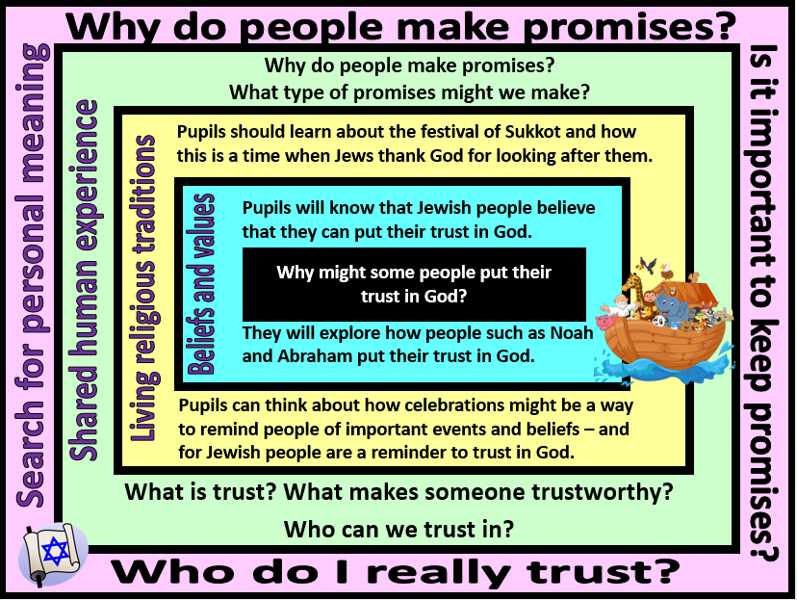

Focus Question: Why might some people put their trust in God?
In this unit, children will have the opportunity to explore Jewish beliefs about God, with a focus on why religious people put their trust in God and how this might be expressed.
They will learn about the story of Noah and the symbol of the rainbow as God’s promise never to send a flood to destroy the world again. They will investigate the festival of Sukkot as an annual reminder to the Jewish community to be thankful to God for all he has done.
Pupils will also have opportunities to talk about why promises and trust are an important aspect of human life. They will think about how we know whether or not people are trustworthy and reflect on their own values about the importance of being someone who is trusted by others.
Field of Enquiry | Possible Teaching Ideas
Shared Human Experience  1 | - Watch http://www.early-years.org/sesame-tree/activity-cards/activity-card.php?acn=14&acs=2 clip and discuss the questions listed beneath the clip. Or share a promise story with the class – eg ‘A promise is a Promise’ by Robert Munsch.  - Circle time - discuss the importance of promises. Ask the children to give examples of promises that they have made within the class. E.g. I promise I will not hit, I promise I’ll wait my turn. Ask why it is important we can trust one another to keep these promises – why is it important to be trustworthy? What makes someone trustworthy?  - Make a class promise and decorate with fingerprints as signatures. Display the promise/s on the wall.
Beliefs and Values  2 | - Read the story of Noah. If you have a toy ark/pairs of animals then the story could be acted out.  - Talk about the rainbow as a sign of God’s promise – talk about why people might need reminders of the importance of promises (link with the class display of their promises). Explain that a Jewish person might say that although people often forget their promises, God does not and so they believe that they can always trust in God.  - Listen to/ learn the song ‘Arky, Arky’ (Rise and Shine)
Living Religious Traditions  3 | - Watch Jumpin’ Jerusalem- Sukkot https://www.youtube.com/watch?v=h_W1pGtlRsY  - Tell the children about the history of the festival of Sukkot and how this is celebrated by Jewish families today.  - Talk about how the celebration of the Sukkot is similar/different to the celebrations some people celebrate each year? Encourage children to understand that celebrations are important in many cultures as a way of remembering something special and often as a reminder to be grateful – in the same way, Sukkot is a time for the Jews to remember to be grateful to God for keeping his promise and providing them with all that they need.  - You could create a Sukkah with in the classroom and decorate with lulavs, etrog, hadass and aravah made from paper.
Search for Personal Meaning  4 | - The class could eat lunch together by the sukkah and talk about how eating together is a nice way of bringing people together as a family/community.  - Look back at the class promises – discuss if they have been kept by all members of the class, do they feel that they will be able to continue to keep these promises throughout the rest of the year, how easy/difficult is it to keep promises?

Y1 Learning - children will:
•Give an example of a key belief (ie. that Jews believe in one God) and/or a religious story (the story of Noah and/or Abraham)  •Give an example of a core value or commitment (trusting that God will keep his promise) | - Use some religious words and phrases to recognise and name features of religious traditions (eg. Sukkot, festival)  • Talk about the way that religious beliefs might influence the way a person behaves (eg. like Noah and Abraham, Jewish people should trust that God keeps his promises) | - Notice and show curiosity about people and how they live their lives (finding out about Jewish festivals – thinking about the fact that people celebrate different celebrations in very different ways – eg. Sukkot)  - Notice that for many people, trust is an important part of human life | - Ask questions (about the importance of trust and who they can trust/rely on in their own lives)
Beliefs and values | Living religious traditions | Shared human experience | Search for personal meaning

