Year 1 Christianity - Jesus
Year1 Key Question (to be used all year): What do people say about God?
Focus Question (for this investigation): Why is Jesus special to Christians?

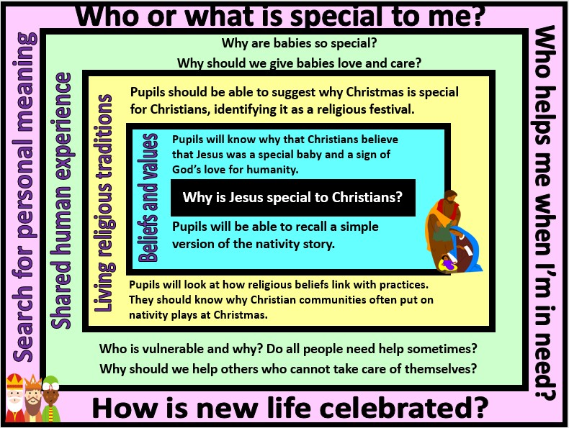

Focus Question: Why is Jesus special to Christians?
This unit gives children the opportunity to explore the Christmas nativity story and to gain an understanding of why Jesus is believed to be a special baby. They should begin to think about why Christmas is a special religious time for Christians (as opposed to simply a cultural tradition of exchanging gifts). The focus of Jesus as a ‘gift’ will introduce children to the concept of the incarnation.
They should also consider how, when and why humans might be vulnerable and in need of help. They should particularly focus on the idea that some people might not be able to help themselves and why helping those in need might be an important shared human value.
Field of Enquiry | Possible Teaching Ideas
Shared Human Experience  1 | - Discuss why family is important. Who is responsible for raising children in a family? What roles do people have in terms of helping one another?  - Read stories with new babies in them. Talk about the fact that babies are both physically and emotionally vulnerable.  - How do people prepare for a new baby? Make a list of important items and ask pupils to select their top three and explain why they chose them.  - Show the class a gift-wrapped box. Tell them that it is the best present ever – ask them what they think it might be and why. Discuss the difference between gifts of financial value and gifts such as love and family and caring.

Beliefs | - Read or watch the Christmas nativity and ask pupils to draw a picture to explain the key parts of the story.  - Pupils to choose three characters from the story and explain why they have chosen them and what their role within the story was. Explain that for Christians, Jesus is God himself and so is the most important character in the story.  - Discuss why Jesus was a special baby: why might Christians describe Jesus as a gift to the world?
and
Values
2
Living | - Talk to a Christian to find out what they think is the important message in the Christmas story.  - Take part in a retelling of the nativity story. Talk about why Christians might retell this story as part of their Christmas celebrations.  - Look at a selection of Christmas cards. Identify which ones have a religious meaning and which do not reflect any religious beliefs or traditions.  - Email a believer. http://www.reonline.org.uk/supporting/. Ask Christians how the Christmas story effects their lives.
Religious
Traditions
3
Search for | - Discuss why people give and receive presents. Why might some people gain pleasure from giving a present?  - Share ideas about non-materialistic presents – Can a person be a present? Why/Why not?  - Relate ideas back to the Christian teaching of Jesus being a gift from God and an expression of God’s love for humanity.
Personal
Meaning
4

Y1 Learning - children will:
* know a simple version | * Identify religious | * Consider how and why | * Talk about their own
of the nativity story. | aspects of Christmas | babies might be special | beginnings and how
* Talk about why | celebrations | – and why they need | they were welcomed
Christians would say | *Talk about why | love and care. | into the family.
that Jesus is a special | Christmas is a special | * Talk about the | * Reflect on who has
baby. | time for Christians | importance of looking | helped them in life so
* Talk about how |  | after those who cannot | far.
different characters in |  | help themselves
the nativity welcome
the baby Jesus
Beliefs and values | Living religious traditions | Shared human experience | Search for personal meaning

