Year 1 Christianity - God
Year 1 Key Question (to be used all year): What do people say about God?
Focus Question (for this investigation): Why do Christians say that God is a ‘Father’?

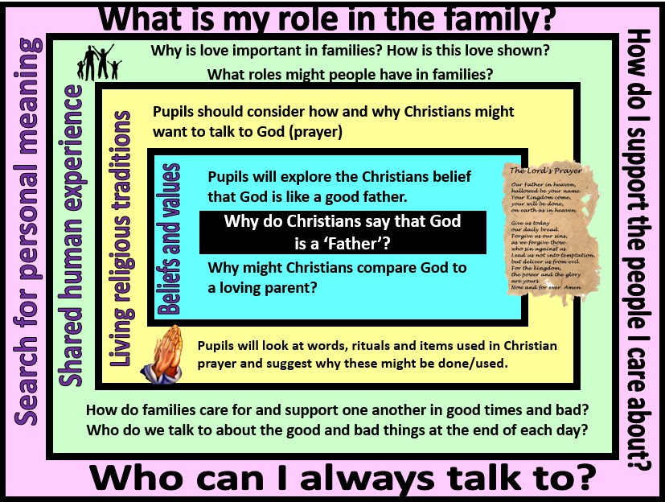

Focus Question: What lights our way?
This unit enables pupils to explore Christian use of the term ‘father’ to address God, especially in prayer (Our Father…). In Hebrew, the term Abba best translates as ‘daddy’, suggesting a loving and personal relationships with God. Pupils should consider the importance of prayer in Christian life. They should reflect on the human need for loving relationships, comfort and someone to talk to – both in good times and bad
Field of Enquiry | Possible Teaching Ideas
Shared | - Look at images of families – talk about the different roles that people have in different types of families.  - In what ways do parents need to care for their children?  - Come up with a class ‘recipe’ for a good parent  - Talk about the importance of love and loving relationships. Suggest ways that people show their love for one another
Human
Experience
1
Beliefs | - Read through the Lord’s Prayer. Talk about why Christians might address God as father. What does this suggest about Christian beliefs about God?  - In the Lord’s Prayer, Christians ask God to give them their daily bread and forgive them their sins. How does this reflect their discussions about a good parent?
and
Values
2

 | - Read a children’s version of the Parable of the Lost Son. Explore the role of the father in the story. What decisions does he make and why? Talk about the fact that in this story, the father represents God – who do the children think the Lost Son represents?
Living | - Look at a range of images of Christians praying in different contexts – alone, in a church, using aids to prayer such as candles, icons and rosary beads. Talk about similarities and differences in the images. Discuss why Christians pray and what says about their relationship with God (as a loving father who listens to their prayers).  - Come up with a list of suggestions – what might a Christian want to talk to God about (encourage ideas such as asking for help, sharing good news, saying sorry, thanking God for all he has done).  - Talk about why Christians might put their hands together in prayer and close their eyes. How might this help them to focus on talking to God?  - Where possible, it would be good to visit a church or invite in a Christian to answer children’s questions about how and why they pray.  - This clip of children talking about praying might also be helpful https://www.youtube.com/watch?v=bS5BFgQWRU4&index=27&list=PLcvEcrsF_9zJxDHG9Jtc CmiAgwVFRW3uK
Religious
Traditions
3
Search for | - Discuss their own roles within the family – as a child what support do they need to grow and succeed? How do they support and care for others in the family?  - Think about who they have to talk to and the types of things they talk about. Why might it be good to talk to someone – about both good things and bad things in the day?  - Children could also think about their own role as a communicator – are they good both at talking and listening?
Personal
Meaning
4

Y1 Learning - children will:
* know that Christians refer | * talk about how and why | * talk about the importance | * reflect on their own role
to God as ‘Father’ | Christians might want to talk | of love in families | within the family
* talk about why Christians | to God | * talk about the ways in | * discuss who they can talk
might compare God to a | * suggest symbolic meanings | which they are cared for and | to when they are
loving parent | of rituals and items used in | supported by family | happy/sad/worried
 | Christian prayer | members
Beliefs and values | Living religious traditions | Shared human experience | Search for personal meaning

